Lester W. Schindler
June 22, 1934 – November 1, 2002

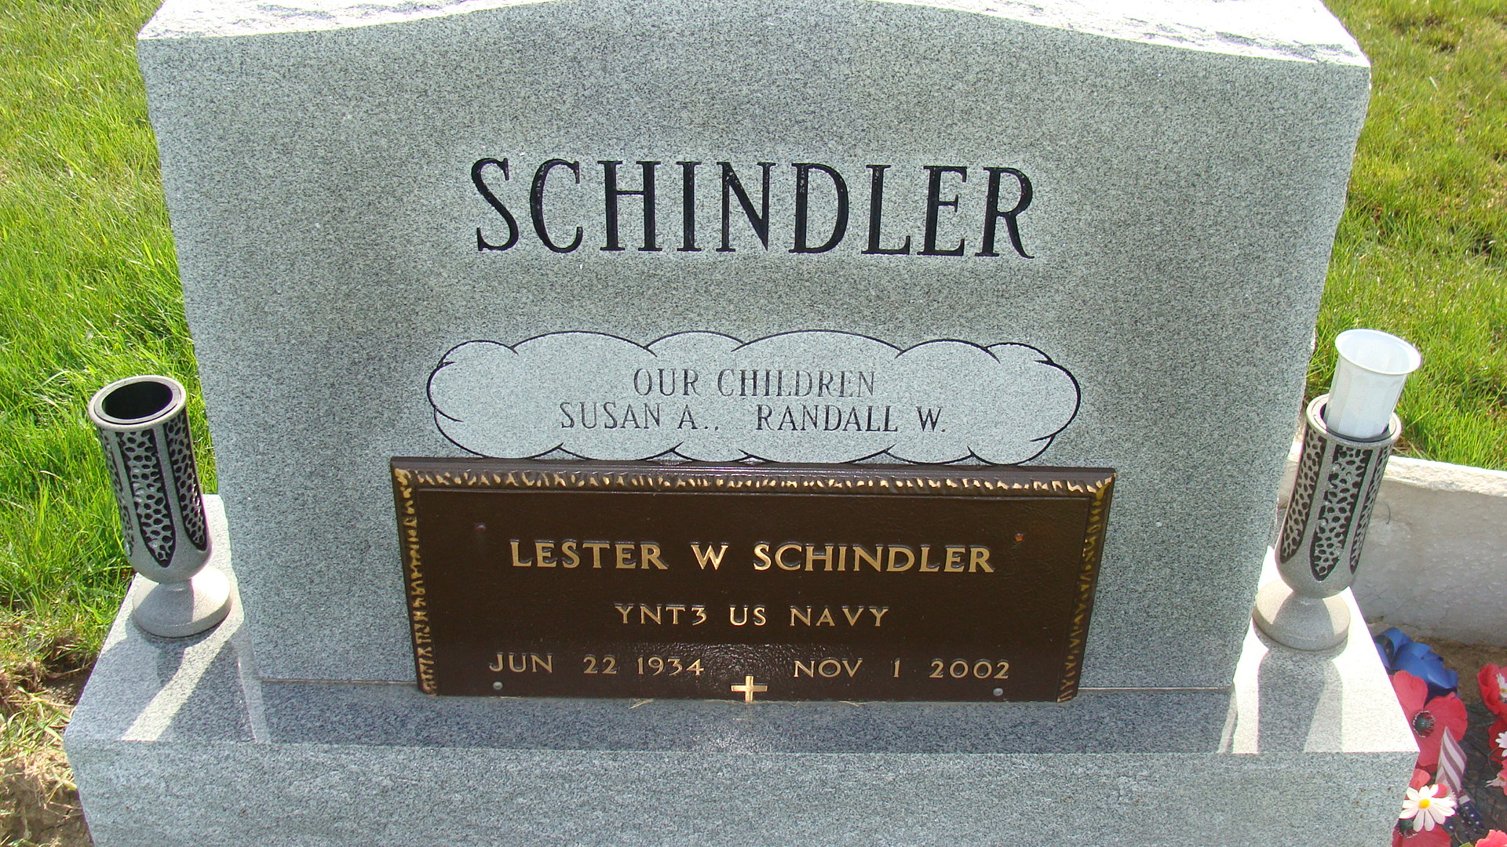
Photo by Alicia Kneuss

Lester W. Schindler, 68, of Geneva, a U.S. Navy veteran, died Friday, Nov. 1, 2002, at Lutheran Hospital in Fort Wayne. The Berne native loved playing pool and was a member of the Decatur American Legion. He retired in 1995 from Central Soya, Decatur.
Surviving are his wife, Beverly A.; a daughter, Susan Heidenreich of Leo-Cedarville; a son, Randy of Berne; sisters Norma Poorman and Harriet Dustman, both of Berne; and two grandchildren. He was preceded in death by a brother.
Services were 10 a.m. today with calling one hour before services. Calling was Sunday at Downing Funeral Home, Geneva. Burial will be at MRE Cemetery, Berne.
Memorials are to Adams County Diabetes Association. Information provided by Downing Funeral Home, Geneva, 1-260-368-7676.

News-Sentinel, The (Allen County, Indiana)
Monday, November 4, 2002

