Kent V. Schindler
September 25, 1936 – August 6, 2021

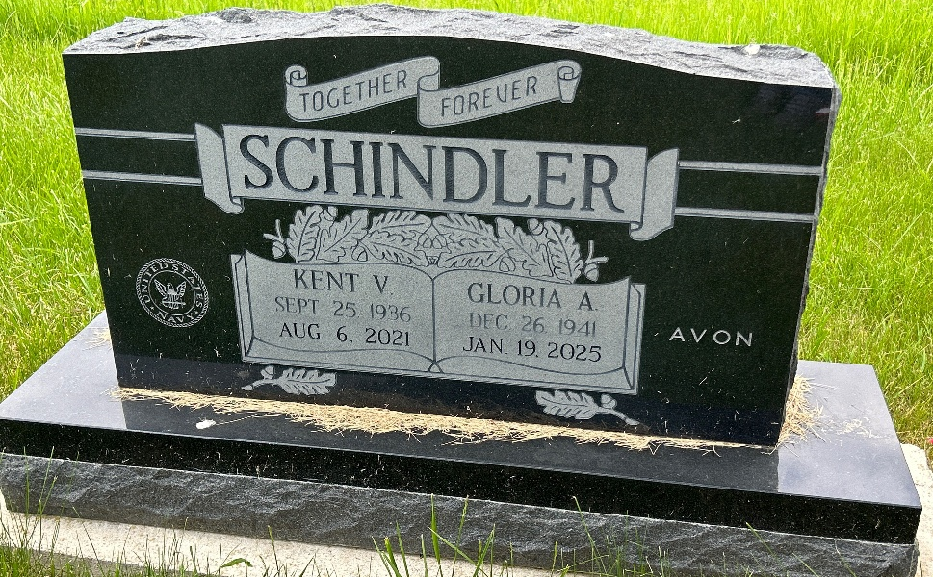
Photo by Barbara Baker Anderson

Kent V. Schindler, 84, of Berne, went to Heaven on Friday, August 6, 2021. He was born on September 25, 1936 to Harold and Velma Schindler, who have preceded him in death. Kent was also preceded in death by his son, Charles Schindler; brother Doug Schindler; brother-in-law Jim Hill and Jerry Bollenbacher.
Kent is survived by his wife, Gloria Schindler; Granddaughter, Erin (Holli) Berry; great-grandchildren, Malakai, Camiela, and Jalynn; sister Claudia Hill; brother Craig (Patty) Schindler; daughter-in-law Lori Schindler; sister-in-law Judy Schindler; and several nieces and nephews.
Kent was a member of the U.S. Navy. He was also a member of the Masons. Kent enjoyed cooking and golfing.
A graveside service will be held on Wednesday, August, 25th at 4pm at MRE Cemetery in Berne, IN.

Liechty Funeral Home, Adams County, Indiana

