Katharena (Neuhauser) Schindler
March 20, 1862 – July 5, 1946

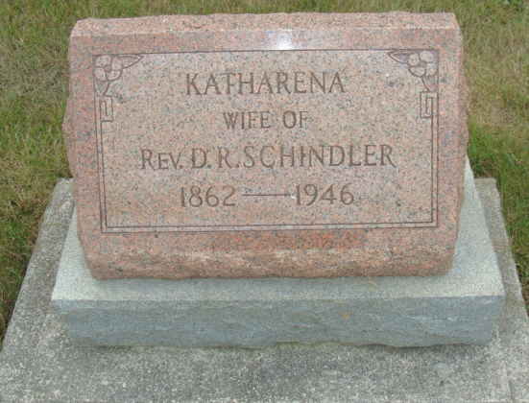
Photo by Alicia Kneuss

Catherine Schindler Dies This Morning
Funeral Services Sunday Afternoon
Mrs. Catherine Schindler, 84, lifelong resident of Adams County, died at 6:45 o’clock this morning at the home of her daughter, Mrs. Noah Rich, south of Monroe. Death was attributed to arteriole sclerosis. She has been in failing health since suffering injuries in a fall last October.
She was born in French Township March 20, 1862, the daughter of Peter and Barbara Schmucker-Neuhauser. She was married April 5, 1885, to David R. Schindler, who died four years later. Mrs. Schindler had made her home with the daughter since 1914.
She was a member of the West Missionary Church, west of Berne.
Surviving in addition to the daughter are two grandchildren. One son preceded her in death.
Funeral services will be held at 1:30 p.m. Sunday at the Rich home, and at 2 o’clock at the West Missionary Church, three miles west of Berne, with the Rev. Oscar Eicher officiating. The body will be removed from the Zwick Funeral Home to the residence Saturday morning.
Adams County, Indiana Historical Museum
1946 June-Sept Scrapbook, Image 10
Handwritten-Fri. July 5, 1946

