Joseph W. Schindler
April 17, 1879 – January 24, 1965

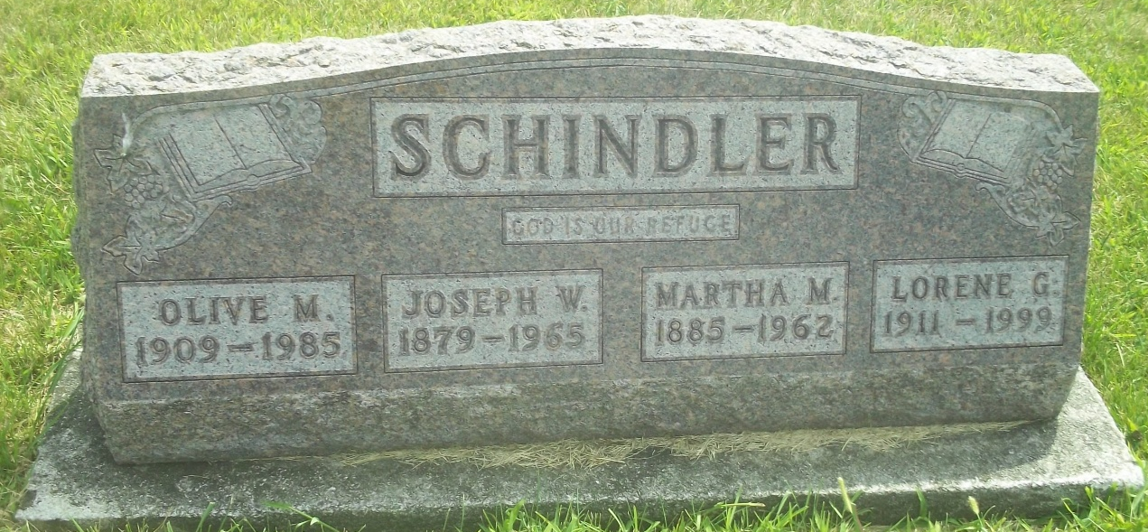
Photo by DSON1492

Indiana, U.S., Death Certificates, 1899-2017

Name Joseph W Schindler
Gender Male
Race Caucasian (White)
Marital Status Widowed
Age 85
Birth Date 17 Apr 1879
Birth Place Indiana
Death Date 24 Jan 1965
Death Place Berne, Adams, Indiana, USA
Death Registration Date 1965
Father Peter D Schindler
Mother Jakabena Zehr
Informant Lorene G. Schindler, daughter
Burial 1/27/1965 M.R.E.

