John W. Schindler
February 3, 1901 – April 15, 1946

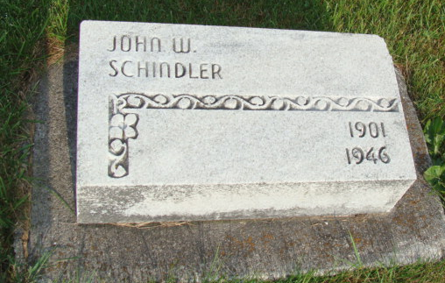
Photo by Alicia Kneuss

Indiana, Death Certificates, 1899-2017
Name John W Schindler
Gender Male
Race White
Age 45y 2m 2d
Marital Status Married
Birth Date 3 Feb 1901
Birth Place Berne, Indiana
Death Date 15 Apr 1946
Death Place Decatur, Adams, Indiana, USA
Death Registration Date 1946
Father Amos Schindler
Mother Sarah Winteregg
Spouse Alieda Schindler, age 45, informant
Burial Cemetery, west of Berne, IN 4/17/1946

