John Henry Schindler
May 13, 1880 – November 30, 1960

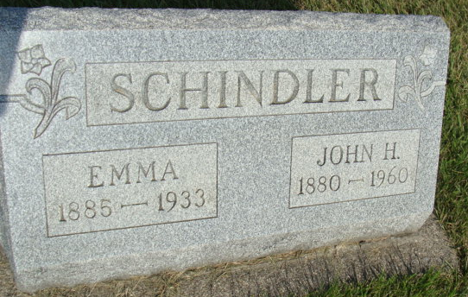
Photo by Alicia Kneuss

Schindler Funeral Services Saturday
John H. Schindler, 80, a resident of Berne most of his life, was found dead in bed Wednesday at the home of a son, Robert Schindler, Angola, where he had been residing. Death was attributed to a heart attack.
Mr. Schindler was a member of the First Missionary Church at Berne.
Surviving are four sons, Floyd Schindler of Ossian, the Rev. Waldo Schindler, a missionary in Africa, Harold Schindler of Berne and Robert Schindler of Angola; two daughters, Mrs. Florence Sheets of Decatur, and Mrs. Margaret Bauserman of Kalamazoo, Mich.; two brothers and three sisters.
Funeral services will be conducted at 2 p.m. Saturday at the Yager Funeral Home in Berne. Friends may call at the funeral home after 12 noon Friday.
Adams County, Indiana Historical Museum
Jan1958-Dec1960 Scrapbook, Image 18
Handwritten-Thurs. Dec. 1, 1960
**
Indiana, U.S., Death Certificates, 1899-2017
Name John H Schindler
Gender Male
Race White
Age 80
Marital Status Widowed
Birth Date 13 May 1880
Birth Place Indiana
Death Date 30 Nov 1960
Death Place Angola, Steuben, Indiana, USA
Father: David Schindler
Mother: Schlatter
Informant: Floyd Schindler; son; Ossian, Indiana
Burial: December 3, 1960; MRE Cemetery; Berne, Indiana

