John Schindler
March 12, 1839 – November 21, 1921

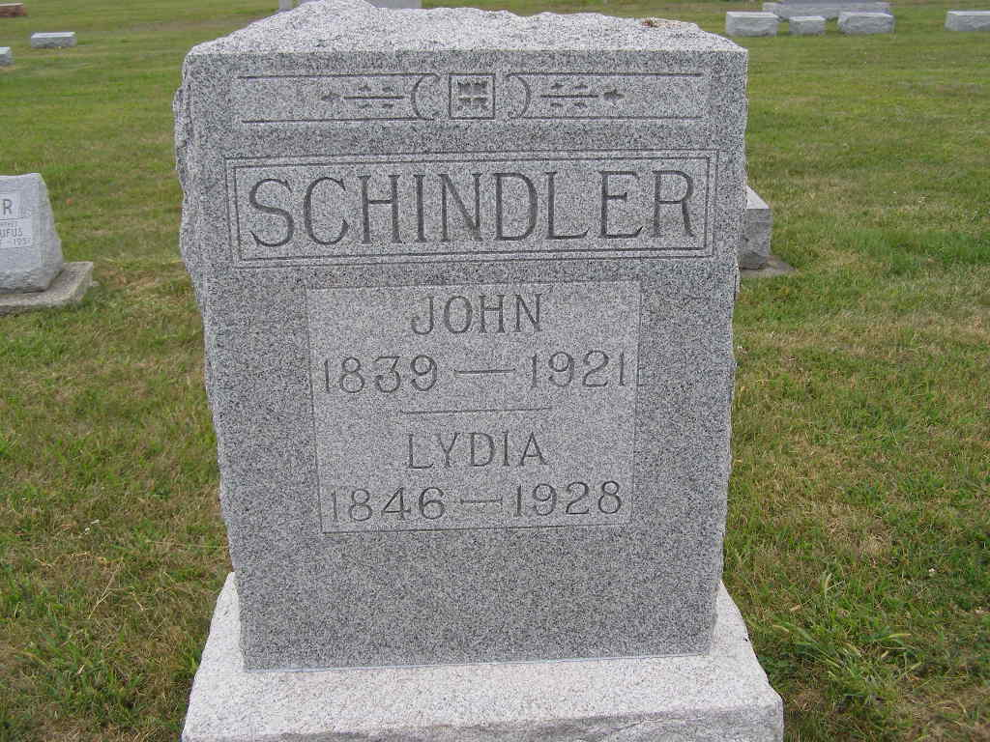
Photo by Shaunda Bedwell Opdycke

Indiana, U.S., Marriage Certificates, 1960-2012

Name John Schindler
Gender Male
Marriage License Date 4 Mar 1869
Marriage Date 9 Mar 1869
Marriage Place Adams, Indiana, USA
Spouse Lydia Auxberger
Officiator J D Gehring
**

Geneanet Community Trees Index

Name John Schindler
Gender M (Male)
Birth Date 12 mars 1839 (12 Mar 1839)
Death Date 21 nov. 1921 (21 Nov 1921)
Father John Schindler
Mother Catherine Moser
**

John Schindler from tree RayWilsonFamilyTree

Birth 12 Mar 1839 Wayne, Ohio, USA
Marriage 9 Mar 1869 Adams, Indiana, USA
Residence 1920 Adams, Indiana, USA
Death 21 Nov 1921 Adams, Indiana, USA
Father Johannes "John" Schindler (1794-1877)
Mother Catherina J Moser (1820-1876)
Spouse Lydia Augsburger (1846-1928)
83156 People 13 Records 22 Sources

