Jacob C. Schindler
February 3, 1868 – March 32, 1947

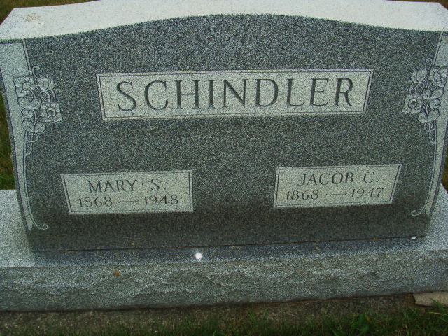
Photo by Alicia Kneuss

Indiana, U.S., Death Certificates, 1899-2017

Name Jacob Schindler
Gender Male
Race White
Marital Status Married
Age 79y 1m 28d
Birth Date 3 Feb 1868
Birth Place Monroe Township
Death Date 31 Mar 1947
Death Place Decatur, Adams, Indiana, USA
Death Registration Date 1947
Father Christian Schindler b. Germany
Mother Barbara Liechty
Spouse Mary Stuckey Schindler
Informant Vilas Schindler
Burial 4/3/1947 M.R.E. Cemetery
**

Indiana, U.S., Marriage Certificates, 1960-2012

Name Jacob C Schindler
Gender Male
Birth Place Indiana
Marriage Date 12 Nov 1891
Marriage Place Adams, Indiana, USA
Residence Place Adams, Indiana
Father Christian Schindler
Mother Barbara Liechty
Spouse Mary Stuckey
Officiator Joseph Rediger

