Jacob Schindler
August 19, 1837 – March 7, 1916

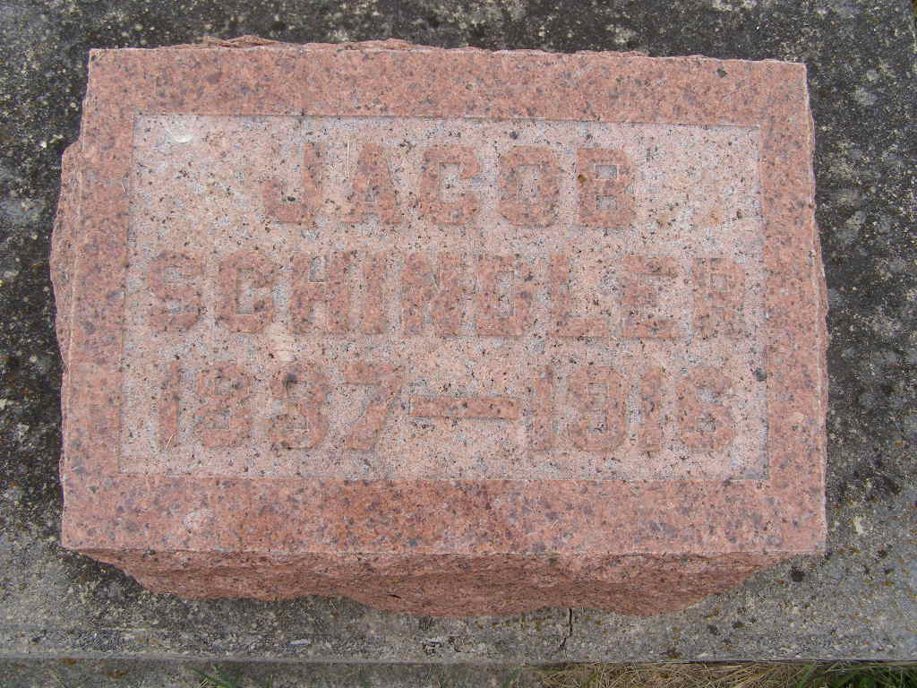
Photo by Shaunda Bedwell Opdycke

JACOB SCHINDLER SUCCUMBS TO BRONCHIAL PEUEMONIA
Had Been in for Seven Weeks – End Was Expected Daily
Funeral Friday Forenoon

Last evening at 6:35 another of Berne’s old citizens passed away when Jacob Schindler, in the southwest part of town, succumbed to bronchial pneumonia and throat trouble. About seven weeks ago Mr. Schindler was taken sick with grip which rapidly developed into bronchial pneumonia and other disorders, so that unable to eat anything for the past few weeks. Before his death the trouble in the lungs seemed to leave him, and he experienced more pain in his throat and a difficulty in breathing. This, together with his ripe old age, naturally hastened death.
The deceased was born in Wyne Co., Ohio, on August 19, 1837, which brings his age to 78 years, 7 months and 18 days. When he was a young man he, with his wife, formerly Anna Stucky, moved on a farm, three miles west of Berne, where he farmed till about 11 years ago, when he retired and moved to Berne.
The deceased is the father of five children, Samuel of Ft. Wayne, Mrs. Noah Winteregg, west of Berne, and Henry and Amos, here in town. One sone, David R. Schindler, preceded his father in death. His descendants also include seventeen grandchildren and one great-grandchild, besides three brothers and two sisters.
Funeral arrangement have been made for Friday morning at 8:30 at the house of the deceased and at 9:30 at the Missionary church, west of town. Interment will be made in M. R. E. cemetery.

The Berne Witness, Adams County, Indiana
Wednesday, March 8, 1916

