Irene E. (Affolder) Schindler
May 3, 1913 – May 8, 2000

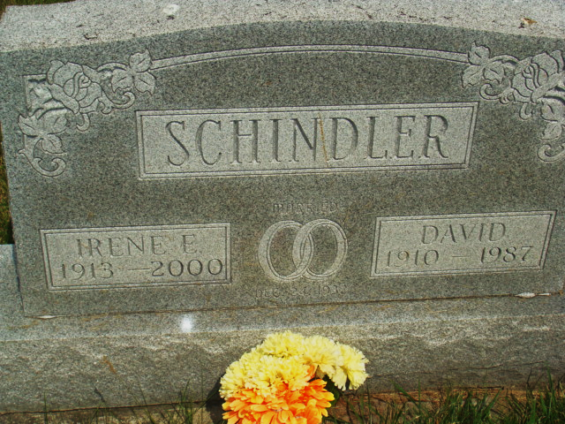
Photo by Alicia Kneuss

Irene E. Schindler, 86, of Berne, former co-owner of a general store in Reiffsburg, died Wednesday, March 8, 2000, at Adams County Memorial Hospital. The Adams County native was also a homemaker, and a member of West Missionary Church and its Ladies Aide. Her hobbies included quilting and crocheting.
Surviving are sons Arthur of Berne and William of Monroe; a daughter, Doris Foster of Wabash; a brother, Ray Affolder of Berne; a sister, Lillian Grogg Bingen of Berne; six grandchildren; and seven great-grandchildren.
She was preceded in death by her husband, David, a sister, Helen Balsiger, and brothers Dale, Howard and Edwin Jr.
Services are 10:30 a.m. Friday at West Missionary Church, Berne, with calling one hour before services. Calling is also from 2 to 9 p.m. today and also from 8 to 9 a.m. Friday at Yager-Kirchhofer Funeral Home, Berne. Burial will be in M.R.E. Cemetery, Berne. Memorials are to church Missions.
Information provided by Yager-Kirchhofer Funeral Home, Berne, 1-219-589-3101.

News-Sentinel, The (Allen County, Indiana)
Thursday, March 9, 2000

