Ida Lois (Weimer) Schindler
August 4, 1912 – January 5, 1985

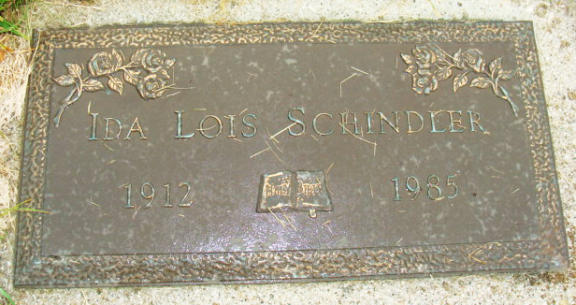
Photo by Alicia Kneuss

Indiana, U.S., Marriages, 1810-2001

Name Ida Lois Weimer
Gender Female
Race White
Age 29
Birth Date 4 Aug 1912
Birth Place Union City, Ohio
Marriage Date 3 Jul 1941
Marriage Place Indiana, United States
Residence Place North Manchester, Indiana
Father Franklin J Weimer
Mother Lillian F Zumbrun
Spouse Ralph Schindler
Page 327
**

Florida, U.S., Death Index, 1877-1998

Name Ida L Schindler
Race White
Age at Death 72
Birth Date 4 Aug 1912
Death Date 5 Jan 1985
Death Place Volusia, Florida, United States

