Henry Schindler
July 11, 1888 – May 4, 1974

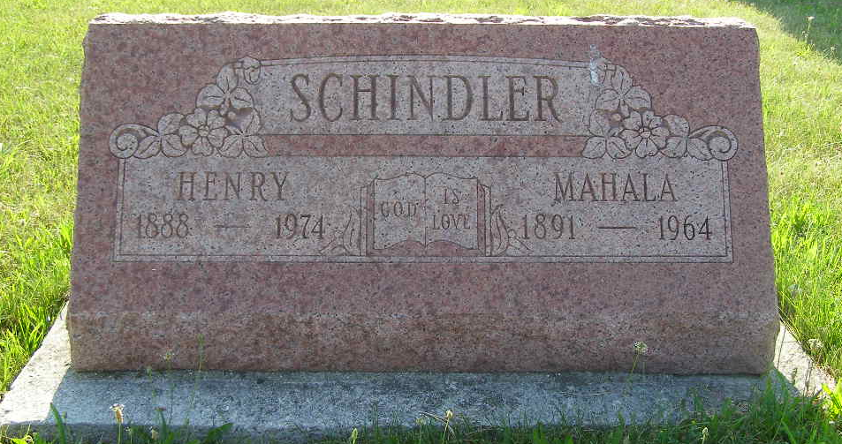
Photo by Shaunda Bedwell Opdycke

Henry Schindler dies Saturday-rites here Tuesday
Henry Schindler, 85, a resident of the community most of his life, died at 11:10 p.m. Saturday at the Decatur Community Care Center. Death was attributed to cancer. Mr. Schindler had been ill since Christmas and in serious condition the last month.
He was a retired Dunbar Furniture Company employee and was associated with the firm for 39 years. He was a member of the Dunbar Quarter Century Club.
Mr. Schindler, a native of Hartford township, was born on July 11, 1888, the son of John Schindler and Lydia (Augsburger) Schindler. He was united in marriage to Mahala?? (??) Biberstein on September 3, 1922 by the Rev. Wm. Egle in their new home on Franklin St. She preceded him in death on December 27, 1964.
He was a lifelong resident of this community except for six years he spent in Fort Wayne and Detroit. Mr. Schindler does not have any immediate survivors, being the last member of his family.
Preceding in death were three brothers and seven sisters, Levi, William and Rufus Schindler and Mrs. William (Judith) Egle, Mrs. John (Mary) Zimmerman, Mrs. Simon (Tillie) Zimmerman and Barbara, Sarah, Susan and Emma Schindler.
The body is at the Yager Funeral home where friends may call and where services will be held at 2 p.m. Tuesday. Dr. Homer W. Achor, pastor of the Trinity United Brethren church of which Mr. Schindler was a member will officiate and burial will be in them. R. E. cemetery.
Preferred memorials are to the American Cancer Society.
Berne (IN) Library Heritage Room
1973-1984 MRE Obit Book Image 55
**
Henry Schindler, 85, of 660 Indiana St., Berne, retired Dunbar Co. employee, died at 11:10 p.m. Saturday at the Decatur Community Care Center. He had been ill since last Christmas. Mr. Schindler was a member of the Trinity Methodist Church. Born in Hartford township on July 11, 1888, he was the son of John and Lydia Augsburger Schindler, and was married on September 3,1922, to Mahala Biber-stein, who preceded him in death. Funeral services will be held at 2 p.m. Tuesday at the Yager funeral home with Dr. Homer Achor officiating. Burial will be in the M.R. E. cemetery. Friends may call at the funeral home after 2 p.m. today. Preferred memorials are to the Cancer Society.

Decatur Daily Democrat, Adams County, Indiana
Monday, May 6,1974

