Harold Schindler
July 7, 1911 – November 11, 1979

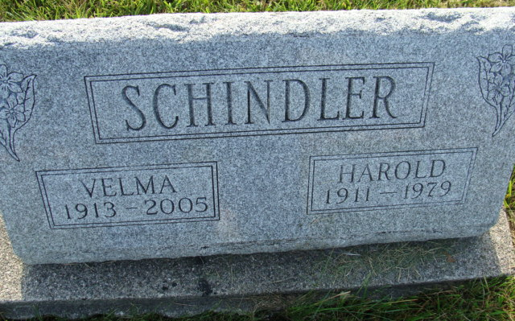
Photo by Alicia Kneuss

Harold Schindler, 68, of Berne, a former Adams County deputy sheriff and prior to that a truck driver for the Dunbar Furniture Co. for 25 years, died at 2 p.m. Sunday at the Adams County Memorial Hospital, following a 10-year illness.
Mr. Schindler was a deputy sheriff for eight years, and also served as a chief deputy. He was forced to retire a number of years ago due to ill health. He was a member of the Trinity United Methodist Church.
Born in Hesperia, Mich., on July 7, 1911, he was the son of John and Emma Stucky-Schindler, and was married in July of 1933 in Kentucky.
Survivors include the wife, Velma; three sons, Doug, Ossian; Kent, Berne; Craig, Indianapolis; one daughter, Mrs. James (Claudia) Hill, Berne; three brothers, Floyd, Van Wert, Ohio; Waldo, Fort Wayne, and Robert, Angola; two sisters, Mrs. Everett (Florence) Sheets, Decatur; Mrs. Carl (Margaret) Bauserman, Kalamazoo, Mich.; and nine grandchildren.
Funeral services will be held at 1:30 p.m. Tuesday at the Yager Funeral Home, with Rev. Howard Rees officiating. Burial will be in the MRE Cemetery. Friends may call at the Berne funeral home after 2 p.m. today.
Preferred memorials are to the Heart Fund or the Cancer Society for cancer research.

Decatur Daily Democrat, Adams County, Indiana
Monday, November 12, 1979

