Hallman W. Schindler
December 6, 1920 – May 14, 1984

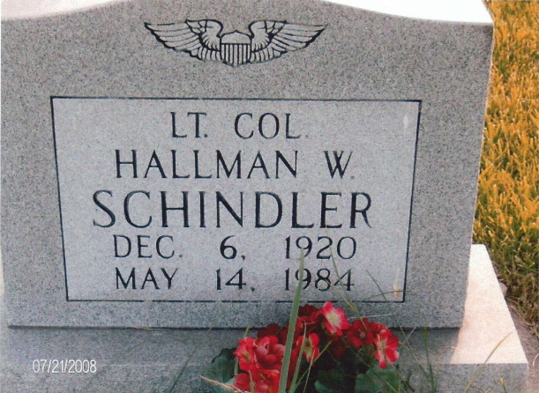
Photo by JC

HALLMAN W. SCHINDLER

Hallman Wayne Schindler, 63, of Satellite Beach, Fla., died at 6:23 Monday in Wuesthoff Memorial Hospital, Rockledge, Fla., after suffering a massive heart attack.
A native of Adams County, Mr. Schindler was a retired U.S. Air Force Lt. Col. Born Dec. 6, 1920, he was the son of John and Elieda- Sprunger.
Survivors include the wife, Linda; two daughters, Mrs. Denny (Sue) Baumgartner of Berne and Mrs. John (Sally) Stuckey of Winchester; one brother, Vaughn Schindler, Berne and five grandchildren.
Funeral services will be held at 2 p.m. Thursday in the First Mennonite Church Chapel, Berne, Dr. Andrew Stoner officiating; burial will be in MRE Cemetery. Friends may call at Yager-Kirchhofer Funeral Home in Berne after 4 p.m. Wednesday, and on Thursday from 9 a.m. to 12:30 p.m., and one hour prior to the service.

Decatur Daily Democrat, Adams County, Indiana
May 15, 1984

