Grace Lucille Schindler
April 10, 1915 – February 6, 1918

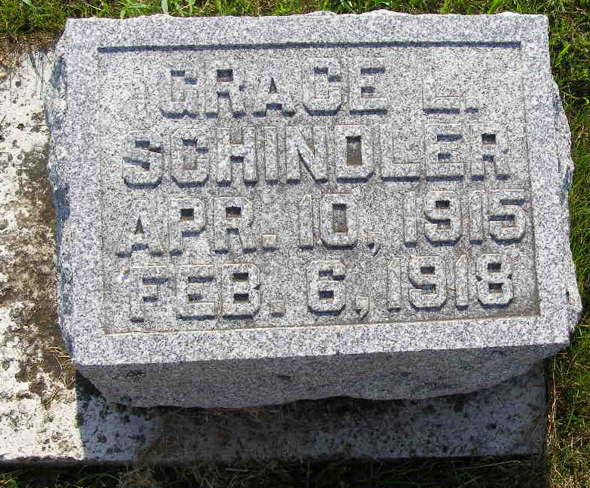
Photo by Shaunda Bedwell Opdycke

Indiana, U.S., Death Certificates, 1899-2017

Name Grace S. Schindler
Gender Female
Race White
Marital Status Single
Age 2y 9m 26d
Birth Date 10 Apr 1915
Birth Place Adams County, Indiana
Death Date 6 Feb 1918
Death Place Monroe, Adams, Indiana, USA
Death Registration Date 1918
Father Joseph Schindler, informant
Mother Martha Moser
Burial M.R.E. Cem 2/9/1918

