Gloria Ann (Bollenbacher) Schindler
December 26, 1941 – January 19, 2025

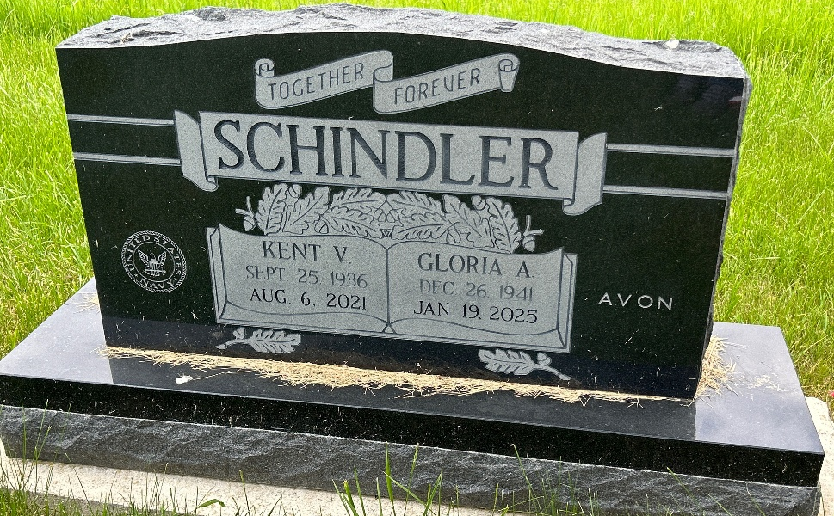
Photo by Barbara Baker Anderson

Gloria Ann Schindler, born December 26th, 1941, peacefully returned to her family surrounded by those she loved and those that loved her at 7:48p.m. on January 19th, 2025, at Ossian Healthcare.
Gloria served at the Wagon Wheel, was a member of the Masonic Lodge for many years with her husband, was an avid Avon rep and enjoyed traveling with her husband, Kent, who preceded her in death on August 6th, 2021.
Gloria was also a proud mother of her one and only son, Charles 'Chuck' Schindler who preceded her in death on September 26th, 2016.
Gloria was also preceded in death by both of her parents and her brother.
To know Gloria was to love her. She will be greatly cherished and missed by her Ossian Healthcare family who had the honor of caring for her the last 5 years and Kent up until his passing.
A very special thank you to Courtny, Michael and their children who Gloria loved deeply for devoting their time and love to her no matter what.
A big thank you also to the Ossian Healthcare team for loving and caring for Gloria and staying by her side and to the entire Solace Hospice team for keeping Gloria cared for and comforted during her passing.
Per Gloria's wishes, there will be no funeral service. A Celebration of Life will take place and be held at a later date.
'Beloved Mother, Grandmother, Friend and Family Member, your love leaves memories that will live forever in our hearts'.

Liechty Funeral Home, Adams County, Indiana

