Glennys C. (Arnold) Schindler
November 8, 1905 – May 13, 1984

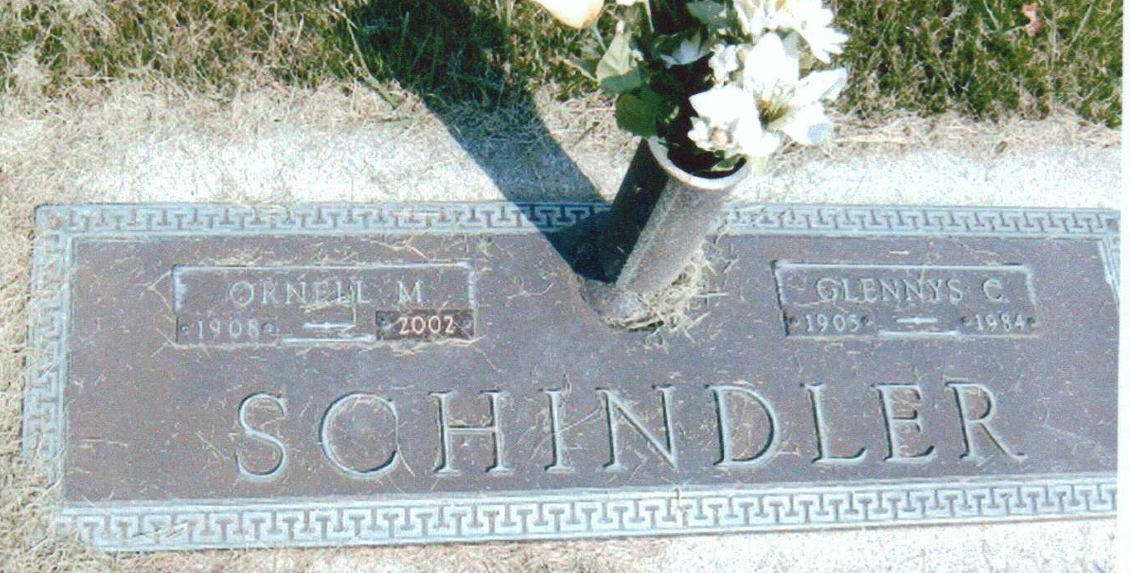
Photo by JC

Glennys C. Schindler, 78, 667 Indiana St., Berne, died at 11 a.m. Sunday in Lutheran Hospital, Ft. Wayne. A native of Adams County and a retired home ec teacher, she taught in the Kirkland High School and taught 21 years in the Berne High School. She was a member of Cross United Church of Christ, Berne.
Born Nov. 8, 1905, she was the daughter of William and Sarah (Jackson) Arnold and was married in Warsaw Aug. 31, 1945, to Ornell Schindler, who survives. Also surviving are two sisters, Mrs. Mary Arnold and Mrs. True (Elsie) Andrews of Decatur; and three brothers, Homer and Kenneth Arnold of Decatur and Vernon Arnold of Benson, Ariz.
Services will be held Wednesday at 10:30 a.m. at the Cross United Church of Christ in Berne, Rev. Robert Kauffman officiating. Friends may call after 1 p.m. Tuesday at the Yager-Kirchhofer Funeral Home, Berne, and at the church Wednesday one hour prior to the service.
Preferred memorials are to the Church Assistance Fund of Cross United Church of Christ, Berne.

Decatur Daily Democrat, Adams County, Indiana
May 14, 1984

