Geraldine (Metzger) Schindler
September 2, 1915 – June 1, 1995

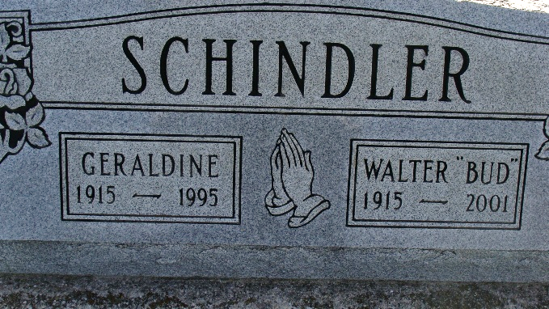
Photo by Alicia Kneuss

Geraldine "Gerri" Schindler, 79, a Delaware, Ohio resident and former Berne resident, died at home at 7:45 p.m. Thursday. She had been ill with cancer. Mrs. Schindler was a retired bookkeeper and a member of First Missionary Church. She was an Adams County resident for 48 years, having moved to Delaware, Ohio six months ago.
Mrs. Schindler was born on September 2, 1915 in Kosciusko County to Cloice and Effie (Parsons) Metzger. She married Walter Schindler on November 23, 1938 in North Manchester. He survives. Other survivors include two daughters, Mrs. Don (Anita) Dyck, Delaware, Ohio, and Mrs. (Nan) Steven Habegger, Knoxville, Tenn.; a sister, Marie Ireland, North Manchester, four grandchildren and one great-grandchild. She was preceded in death by a brother, Harold Metzger.
Funeral services are 2 p.m. Monday at Yager-Kirchhofer Funeral Home. Burial will follow in MRE Cemetery. Visiting hours are 3 - 8 p.m. Sunday and 9 a.m. to the time of services Monday at the funeral home.
Memorials are to Missionary Women's International (Women's Ministry), First Missionary Church, or Hospice at Grady, Grady Memorial Hospital in Delaware, Ohio.

Adams County (IN) Public Library
Obit book
Handwritten date: Friday, June 2, 1995

