Florence A. Schindler
January 17, 1905 – October 8, 1977

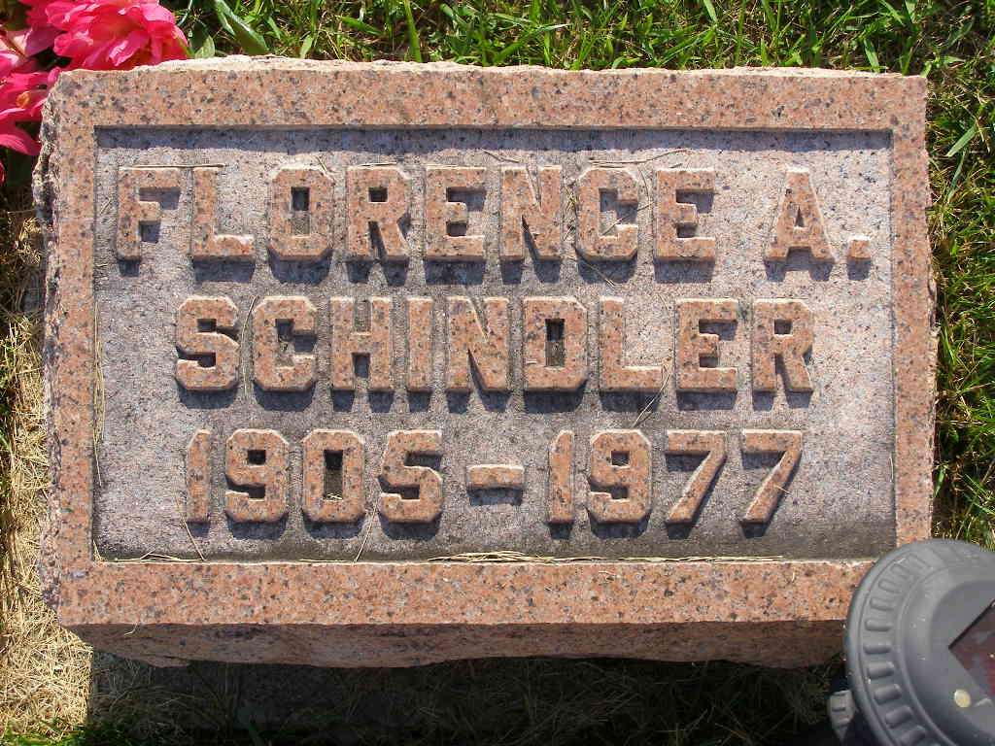
Photo by Shaunda Bedwell Opdycke

Indiana, U.S., Death Certificates, 1899-2017

Name Florence A Schindler
Gender Female
Race White
Marital Status Never Married (Single)
Age 72
Birth Date 17 Jan 1905
Birth Place Indiana
Death Date 8 Oct 1977
Death Place Berne, Adams, Indiana, USA
Death Registration Date 1977
Father Reuben Schindler
Mother Emma Mettler
Informant Ms. Dana Pursley, niece
Burial M.R.E. 10/11/1977

