Eugene Merlin Schindler
September 2, 1932 – March 26, 1984

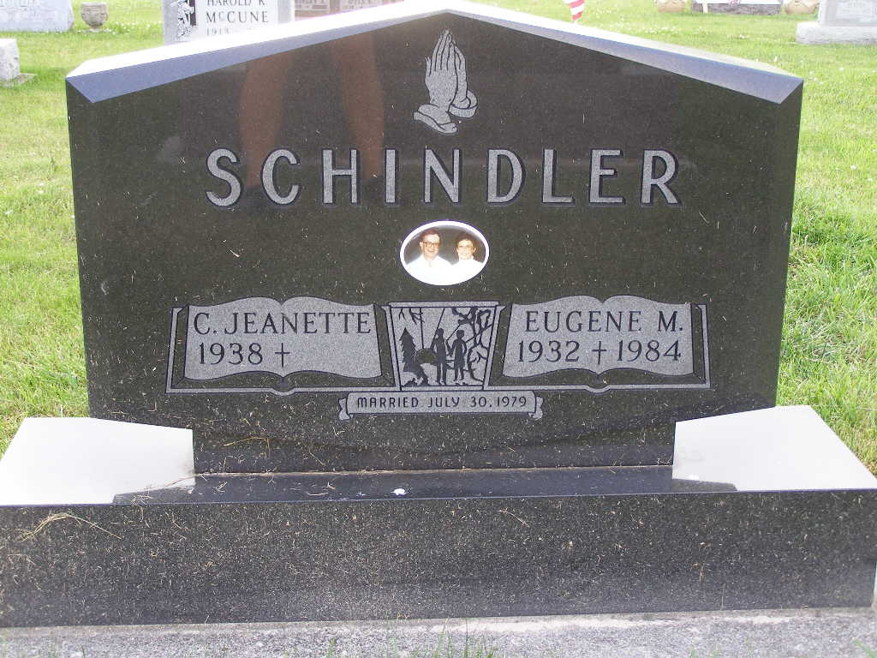
Photo by Shaunda Bedwell Opdycke

Indiana, U.S., Death Certificates, 1899-2017

Name Eugene M Schindler
Gender Male
Race White
Marital Status Married
Age 51
Birth Date 2 Sep 1932
Birth Place Indiana
Death Date 26 Mar 1984
Death Place Decatur, Adams, Indiana, USA
Death Registration Date 1984
Father Marcus Schindler
Mother Mildred L Morningstar
Spouse Jeanette Voltz Schindler, informant
Burial M.R.E. Cemetery 3/30/1984

