Emma (Stucky) Schindler
January 28, 1885 – November 24, 1933

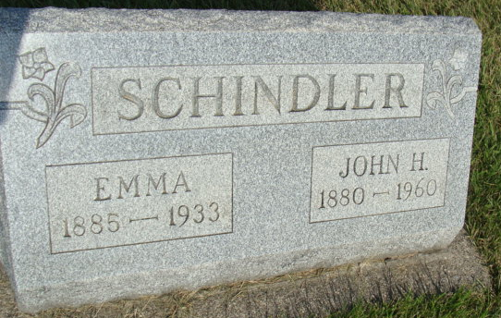
Photo by Alicia Kneuss

Mrs. Schindler Buried Sunday
Mrs. John Schindler, 48, Died Last Thursday Evening.
Funeral services for Mrs. John Schindler, aged 48, who died last Thursday evening at her home here, were held Sunday P.M. at 1:30 o'clock at the home and at 2 at the local Missionary church. Burial was in the M. R. E. cemetery.
Mrs. Schindler died Thursday evening at 5:10 o'clock after a lengthy illness of gallstones, cancer, and complications. She had been sick thirteen weeks, but had ailed previous to that time. She underwent an operation at the Adams County Memorial Hospital several weeks ago and suffered greatly. For several days she was at the point of death, then rallied slightly, but her condition again became critical today a week ago.
Mrs. Schindler, formerly Emma Stucky, was born in French twp., on June 28, 1885, a daughter of Nicholas and Elizabeth Augsburger Stucky. She was 48 years, 5 months and 2 days old at the time of her death. On July 11, 1903, she was married to John Schindler.
Surviving are the husband, four sons and two daughters. They are Floyd of Berne, Waldo of Detroit, Florence at home, Harold of Berne and Margaret and Robert at home. The father, Nicholas Stucky, and the following brothers and sisters survive: William Stucky, Monroe; Levi Stucky, Berne; Mrs. Rollie Elzey, Churubusco; Mrs. Amos Moser, Berne; Mrs. John Barkman, Berne, and Rufina Stucky, also of this place. One brother, Samuel and her mother preceded her in death. Three grandchildren also survive.

Berne Witness, Adams County, Indiana
Monday, December 4, 1933

