Ellowyne M. "Elly" [Neuenschwander) Schindler
August 6, 1925 - April 3, 2007

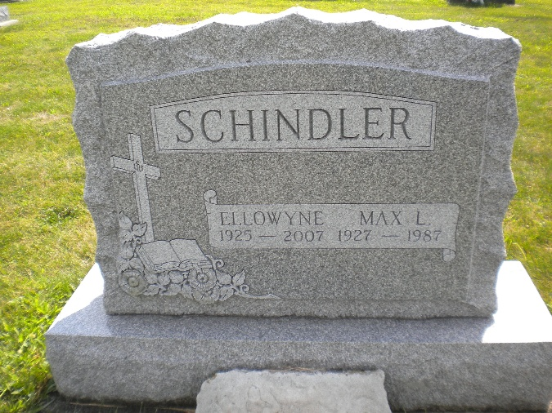
Photo by DSON1492

Ellowyne M. "Elly" (Neuenschwander) Schindler, 81, of Berne, beloved mother, grandmother, sister, and friend, passed away to her Heavenly home on Tuesday, April 3, 2007 at Select Hospital in Fort Wayne. She was born on August 6, 1925 to Joel and Cora (Winteregg) Neuenschwander. She married Max L. Schindler on March 31, 1951. He preceded her in death on January 12, 1987.
She was a member of the West Missionary Church and retired from CTS in Berne. She was a special lady who touched many lives and will be missed and remembered by all who knew her.
She is survived by daughters, Joanne and Marsha Schindler of Fort Wayne, daughter-in law Linda (Jack) Bartlett of Fort Wayne, granddaughters, Valerie (Mark) Bredow of Clarkstone, MI, Stephanie (Nathan) Gleaves of Kearney, NE, Jennifer Schindler of Lake Orion, MI, grandson Jonathan Schindler of Wheaton, IL, sisters Vergene Yake, Floine (George) Dynes, Ramona Schwartz, twin sister Willodyne (Harry) Luginbill, Marjorie (Bill) Simon; brothers Delmar (Dessie) Neuenschwander and LeOrace Dale (Betty) Neuenschwan-der, brother and sister-in laws Norma (John) Poorman and Beverly Schindler (James) Richard.
She was preceded in death by her husband Max, one son Rev. Thomas Schindler, her parents Joel and Cora Neuenschwander, brother and sister-in-law Sherman & Ruth Neuenschwander, parents-in-law Alton & Lillie Schindler, sister-in-law Harriet Dustman and brother-in-laws Lester Schindler, Evan Yake and Harry Schwartz.
Memorial Service is on Saturday, April 7, at 10:00 a.m. at West Missionary Church. Visitation is from 4:00-8:00 p.m. on Friday, April 6 at Yager-Kirchhofer Funeral Home and at the church one hour prior to the 10:00 service. Officiating is Rev. Keith Rupp. Burial in MRE Cemetery. Memorials to West Missionary Church.

Yager-Kirchhofer Funeral Home, Adams County, Indiana

