Ellen Schindler
April 15, 1889 – June 25, 1979

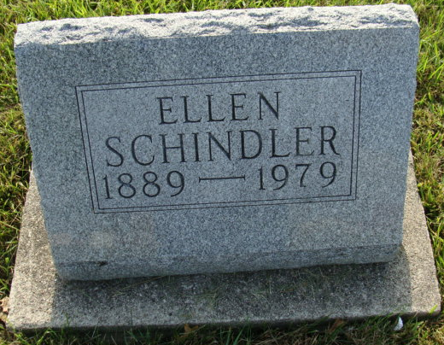
Photo by Alicia Kneuss

ELLEN SCHINDLER
Miss Ellen Schindler, 90, Swiss Village, Berne, a native of that city, died at 6:15 a.m. today at her residence. She was a member of the First Missionary Church, Berne.
Born in Berne on April 15, 1889, she was the daughter of Mr. and Mrs. David Schindler.
Three sisters and eight (cut off)

Decatur Daily Democrat; Adams County, Indiana
Monday, June 25, 1979
**
Indiana, U.S., Death Certificates, 1899-2011
Name: Ellen Schindler
Gender: Female
Race: White
Age: 90
Marital status: Never Married (Single)
Birth Date: 15 Apr 1889
Birth Place: Indiana
Death Date: 25 Jun 1979
Death Place: Berne, Adams, Indiana, USA
Father: David Schindler
Informant: Brice Bauserman; Berne, Indiana
Burial: June 27, 1979; MRE Cemetery; Berne, Indiana

