Elizabeth Schindler
March 17, 1874 – February 6, 1966

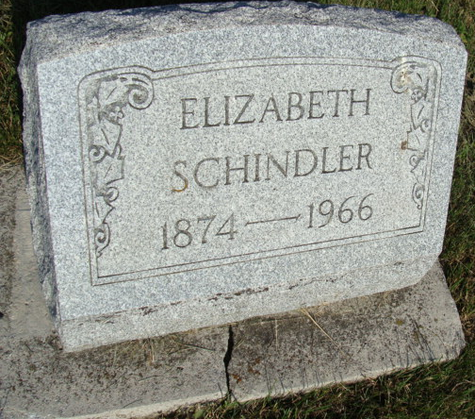
Photo by Alicia Kneuss

Elizabeth Schindler

Miss Elizabeth Schindler, 91, a resident of this community most of her life, died at 7 a.m. Sunday at the Berne Nursing home where she resided. She had been in failing health for several years.
A native of French township, Miss Schindler was born March 17, 1874, a daughter of David and Catherine Schlatter Schindler. She moved with her parents to Hesperia, Michigan where they resided for 15 years, then moved back to Berne.
Surviving are two sisters, Mrs. Henry (Cassie) Winteregg of Berne and Miss Ellen Schindler of Fort Wayne and a brother, Samuel Schindler, Berne. A brother and seven sisters preceded in death.
Miss Schindler was a member of the First Missionary church. The body is at Yager Funeral home where friends may call after 7 p.m. today. Services will be held at the funeral home at 1:30 p.m. Tuesday. Rev. Gerald Gerig, pastor of the First Missionary church, officiating. Burial will be in the M.R.E. cemetery.

Date of death 06 Feb 1966 Date of burial 08 Feb 1966

Berne (IN) Public Library Heritage Room
MRE Obit Notebook, image 005

