Edna (Beer) Schindler
June 10, 1904 – February 24, 1991

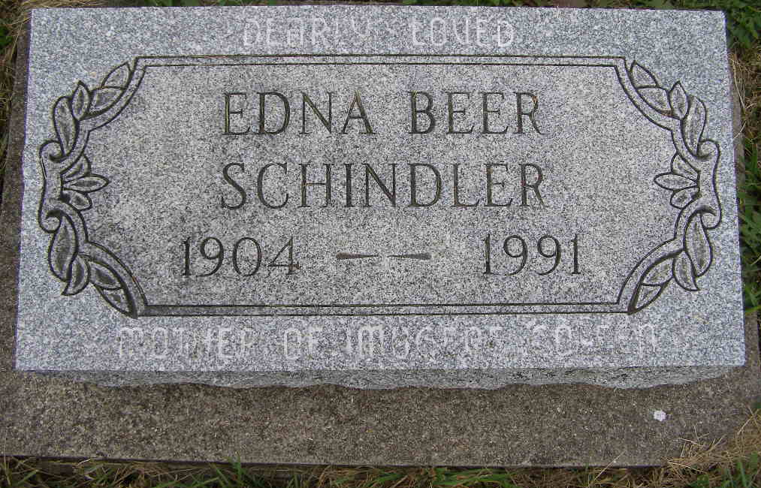
Photo by Shaunda Bedwell Opdycke

Edna Schindler, 86, Berne, died at 2:50 a.m. Sunday in Swiss Village, her residence since November, 1983. She lived many years in Berne prior to moving to Swiss Village. She was born in Adams County on June 10, 1904 to Christian C. and Sara (sic) Ellenberger Beer.
She twice worked as a telephone operator: 1941-50 at the Berne office of Citizens Telephone Co. and 1965 until retirement in 1972 for United Telephone Co. at Decatur. From 1951-65, she was a secretary for G. C. Moser Insurance in Berne. She was a member of Cross United Church of Christ and its Dorcas Circle.
Surviving are two daughters, Mrs. Denver (Coleen) Rich, Berne, and Mrs. Howard (Imogene) Moser, Tucson, Arizona; one sister, Rosella Nussbaum, Berne; one brother, Elmer C. Beer, Berne; six grandchild- ren; four step-grandchildren; five great grandchildren; and eight stepgreat-grandchildren. Six sisters, five brothers and one stepgrandchild are deceased.
Funeral services are at 2 p.m. Tuesday in Cross United Church of Christ, Dr. William Huenemann officiating. Burial will be in MRE Cemetery, Berne. Visiting hours are 2-9 p.m. today and 9-12:30 p.m. Tuesday in Yager-Kirchhofer Funeral Home, Berne, and 1-2 p.m. Tuesday in the church. Preferred memorials are to the church or Swiss Village.

Decatur Daily Democrat, Adams County, Indiana
Monday, Feb. 25, 1991

