David Schindler
November 19, 1849 – July 29, 1933

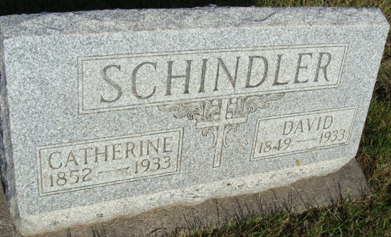
Photo by Alicia Kneuss

David Schindler, who for over a third of a century has owned and operated a splendid farm in French township, Adams county, Indiana, and who, during all these years, has lived an honorable and upright life among his fellow citizens, was born in French township on November 19, 1849. He is the son of John and Catherine (Moser) Schindler, the former of whom was born in Germany, but came to the United States at an early date.
He first worked as a farm hand in New York state for eight years for one man and then came to Wayne county, Ohio, where he farmed again until his removal to Adams county in 1846. He first settled in French township, which was at that time in a very unsettled condition. He here cleared and improved a fine farm, which he operated up to the time of his death. He was the father of seven children: Jacob, John, Christ, deceased; Peter, Catherine, David, Sarah.
The subject of this sketch received his education in the schools of his locality and was early inured to the life of a farmer. He is the owner of eighty acres of fine land, on which are raised all the crops common to this latitude and also gives some attention to the breeding and raising of Poland China and Duroc hogs.
January 7. 1872, Mr. Schindler was married to Miss Catherine Schlatter, daughter of Joseph and Elizabeth (Augusberger) Schlatter, who came here in an early day and settled in French township, where they followed farming. Both are now deceased. Catharina Schindler died December 19, 1876, aged fifty-six years, two months and sixteen days. John S. died August 12, 1877, aged eighty-two years. Joseph Schlatter died September 31, 1872, aged fifty-four years, eleven months and four days. Elizabeth S. died December 15, 1897, aged eighty-three years, nine months and ten days.
To the subject and his wife have been born twelve children, whose names, with the years of their birth, are as follows: Noah, who was born in 1872; Lizzie, 1874; Cassie, 1875; Elmer, 1877; Joseph, 1878; John, 1880; Samuel, 1882; Menno, 1884; Simon, 1886; Ella, 1889; Edwin, 1891; Selena, 1894. The family are members of the Missionary church and occupy a high position in the community.

Snow's History of Adams County, Indiana, John Fletcher Snow,
B. F. Bowen, Indianapolis, IN, 1907, p. 401 (image 821
**

David Schindler from tree Yoder-Rupp Families

Birth 19 Nov 1849 Adams, Indiana, USA
Marriage 1872
Residence 1930 Berne, Adams, Indiana, USA
Death 29 Jul 1933 Berne, Adams, Indiana, USA
Father John * Schindler (1801-1877)
Mother Katherina J Moser (1820-1876)
Spouse Catherine Schlatter (1852-1933)
189753 People 19 Records 21 Sources

