David Schindler
December 28, 1910 – January 31, 1987

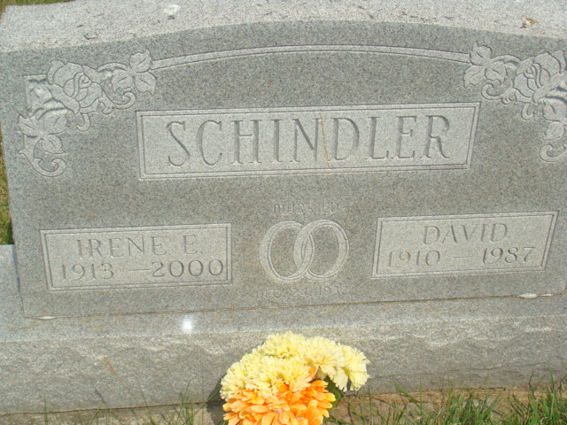
Photo by Alicia Kneuss

Indiana, Death Certificates, 1899-2017

Name David Schindler
Gender Male
Race White
Marital Status Married
Age 76
Birth Date 28 Dec 1910
Birth Place Indiana
Death Date 31 Jan 1987
Death Place Decatur, Adams, Indiana, USA
Death Registration Date 1987
Father Menno Schindler
Mother Lucy Moser
Spouse Irene Affolder Schindler, informant
Burial M. R. E. 2/3/1987

