Clara Schindler
March 16, 1903 – July 20, 1985

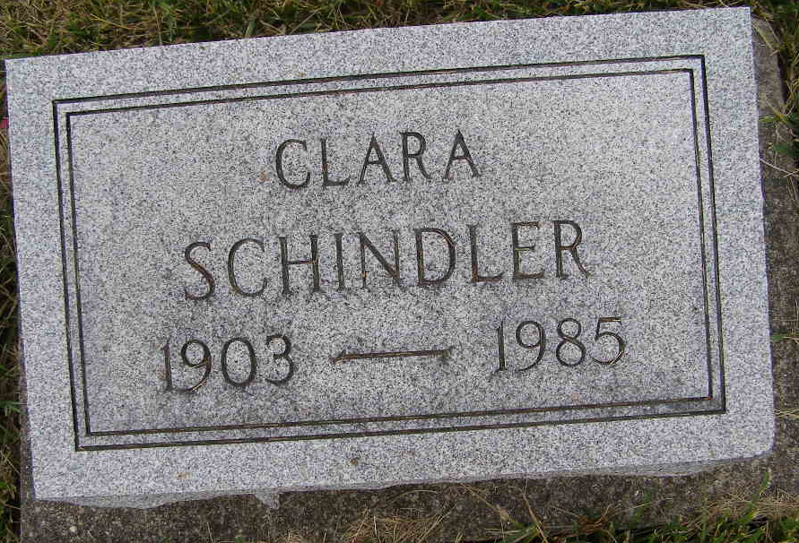
Photo by Shaunda Bedwell Opdycke

Indiana, U.S., Death Certificates, 1899-2017

Name Clara Schindler
Gender Female
Race White
Marital Status Never Married (Single)
Age 82
Birth Date 16 Mar 1903
Birth Place Indiana
Death Date 20 Jul 1985
Death Place Portland, Jay, Indiana, USA
Death Registration Date 1985
Father Amos Schindler
Mother Sarah Winteregg
Informant Walter Schindler, brother
Burial M.R.E. 7/24/1985

