Charles K. Schindler
January 26, 1959 - September 23, 2016

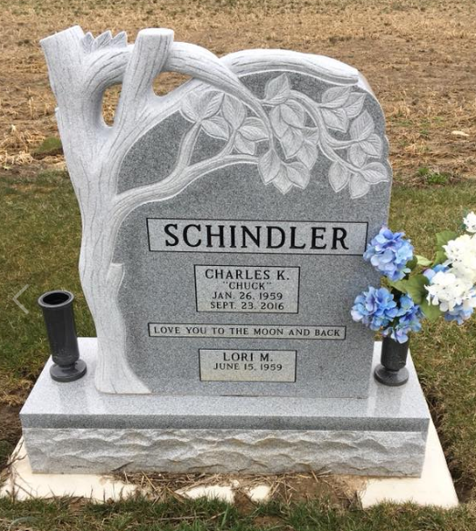
Photo by Scott Shoup

Charles K. "Chuck" Schindler, 57, Berne went home to Heaven on Friday September 23, 2016 at Lutheran Hospital, Fort Wayne, IN. He was born to Kent and Gloria Bollenbacher Schindler on January 26, 1959 in Adams County. He married Lori Madison on September 20, 1980 who survives.
Chuck was presently employed at Entrada Corp, Brentwood, TN as a medical transcriber the last 5 years and prior at EP Graphics, Berne for 28 years. He enjoyed music, nature, animals and woodworking
Surviving is his wife, Lori, daughter, Erin Berry and daughter-in-law, Holli Brigner of Berne, 3 grandchildren; Malakai Berry, Camiela Berry, Jalynn Guereca of Berne, parents, Kent and Gloria, mother-in-law, Judy Hai of Big Sandy, Tn., brother-in-law, Todd Madison of Springville, TN.
Funeral services are Tuesday, September 27, 2016 at 11:00am at Yager-Kirchhofer Funeral Home, Berne with visitation from 10:00am to time of services. Officiating is Pastor Dathen Foust. Burial is in the MRE Cemetery. Preferred memorials to the Family.
Zwick & Jahn Funeral Home, Adams County, Indiana

