Catherine (Schlatter) Schindler
August 9, 1852 – December 21, 1933

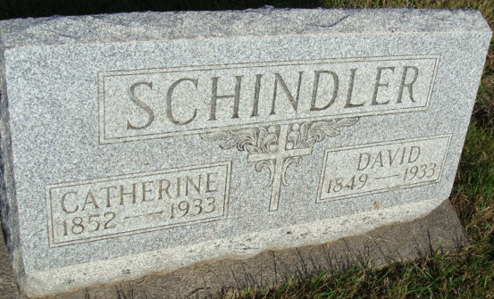
Photo by Alicia Kneuss

Indiana, U.S., Death Certificates, 1899-2017

Name Catherine Schindler
[Catherine Schlatters]
Gender Female
Race White
Marital Status Widow
Age 81y 4m 12d
Birth Date 9 Aug 1852
Birth Place Indiana
Death Date 21 Dec 1933
Death Place Berne, Adams, Indiana, USA
Death Registration Date 1933
Father Joseph Schlatter b. Switzerland
Mother Elizabeth Augsburger b. Switzerland
Spouse David Schindler
Informant Edw. Schindler
Burial M.R.E. Cemetery 12-24-1933

