Cecile Jeanette (Voltz) Schindler
April 8, 1906 – December 18, 1990

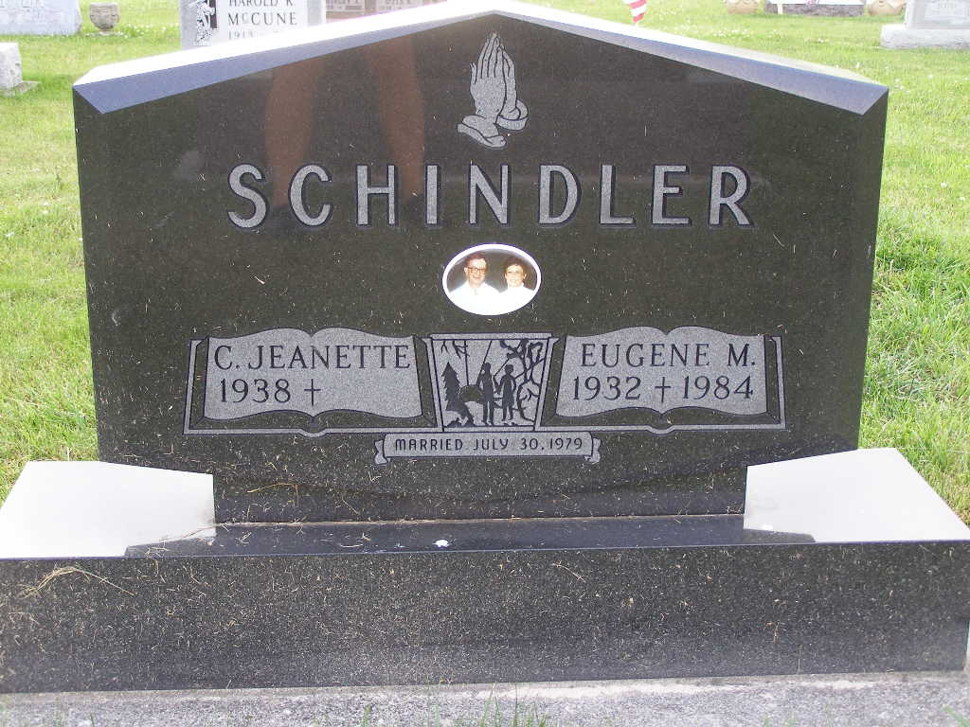
Photo by Shaunda Bedwell Opdycke

Cecile J. Schindler, 81, Decatur, passed away Sunday, July 26, 2020, at her residence. She was born in Willshire, Ohio, July 28, 1938, to the late Ernest and LaVera (Neiferd) Voltz. Cecile was a member of the Eastern Star and the Moose Lodge.
Among survivors are her three sons, Colin Hirschy of Conowingo, Maryland, Rodney (Ann) Hirschy of Whitepost, Virginia, and Kevin (Julie) Hirschy of South Lake, Texas; her fiance, Ronald Stetler of Decatur; step-daughter, Ronda Dorworth of West Chester, Ohio; sister, Yvonne (Merideth "Bob") Brock of Florida; nine grandchildren and 10 great-grandchildren.
She was preceded in death by a son, Gregg A. Hirschy, July 1966; two brothers, Robert "Buck" and Raymond "Buddy" Voltz; and two sisters, Ruthann Straley and Eleanor Jones.
Visitation will be from 1-3 p.m. Aug. 5 at Haggard-Sefton-Hirschy & Zelt Funeral Home, followed by a 3 p.m. funeral service. Pastor Jay Carter will officiate and burial will follow in MRE Cemetery.
Preferred memorials are to the ACCF Angel Cancer Fund.
Online condolences may be made at www.hshfuneralhome.com.

Decatur Daily Democrat, Adams County, Indiana
Jul. 28 to Jul. 29, 2020

