Barbara Schindler
September 30, 1880 – August 28, 1928

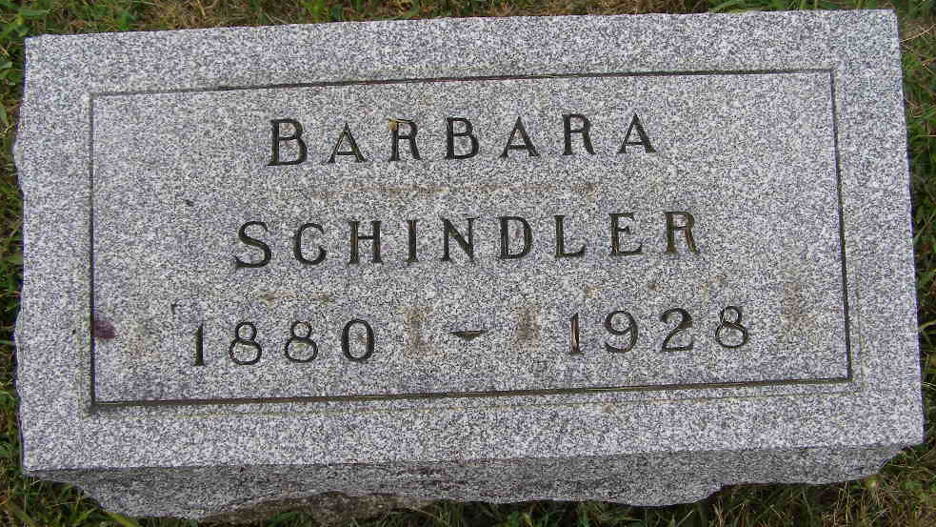
Photo by Shaunda Bedwell Opdycke

Indiana, U.S., Death Certificates, 1899-2017

Name Barbara Schindler
Gender Female
Race White
Marital Status Single
Age 47y 10m 28d
Birth Date 30 Sep 1880
Birth Place Indiana
Death Date 28 Aug 1928
Death Place Hartford, Adams, Indiana, USA
Death Registration Date 1928
Father John Schindler
Mother Lydia Augsburger
Informant Levi Schindler
Burial M.R.E. Cemetery 8/31/1928

