Arvilla N. (Lehman) Schindler
October 6, 1906 – December 16, 1939

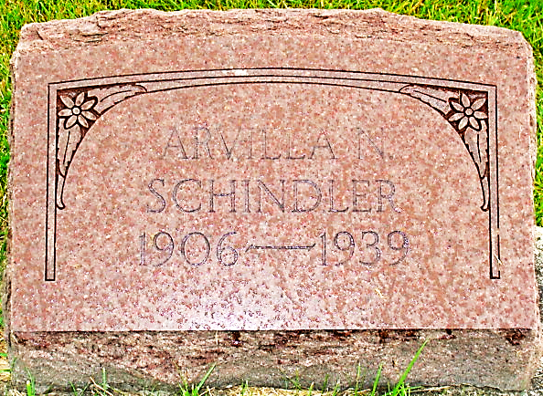
Photo by Alicia Kneuss

Former Berne Resident Dies
Mrs. Ralph Schindler Dies Saturday Night at Wabash Hospital

Mrs. Ralph Schindler, 33, of North Manchester, died at 5:30 pm Saturday at the Wabash Hospital following an emergency operation performed Saturday morning. She had been ill several days, suffering from gall stones.
The deceased was born in Berne, October 6, 1906, a daughter of Carl and Bertha Liechty Lehman. She was married to Ralph Schindler and lived in Berne until two years ago when Mr. Schindler accepted a position in a furniture factory in North Manchester.
She is survived by her husband and three sons, (torn name), Keith and Robert, the parents, Mr. and Mrs. Carl Lehman of Berne, and the following brothers and sisters: Ellis and Mark Lehman and Mrs. Robert Harker, all of Berne, Arthur of North Manchester and Paul of Peru.
Funeral services were held at the home in North Manchester this afternoon at 2:30 o’clock after which the body was brought to the Lehman home in Berne. Funeral services will be held Tuesday at 2 pm in the Mennonite Church in Berne, with burial in the MRE Cemetery.

Adams County (IN) Historical Museum
1939 Scrapbook
Monday, December 18, 1939
**

U.S., Death Certificates, 1899-2011
Name: Arvilla Schindler
[Arvilla Lehman]
Gender: Female
Race: White
Age: 33y 2m 10d
Marital status: Married
Birth Date: 6 Oct 1906
Birth Place: Indiana
Death Date: 16 Dec 1939
Death Place: Wabash, Wabash, Indiana, USA
Death Registration Date: 1939
Father: Carl H. Lehman
Mother: Bertha Liechty
Spouse: Ralph Schindler
Informant: R. E. Schindler of North Manchester, IN
Burial: Berne, Indiana; Dec. 19, 1939

