Anna (Stucky) Schindler
May 4, 1838 – March 26, 1919

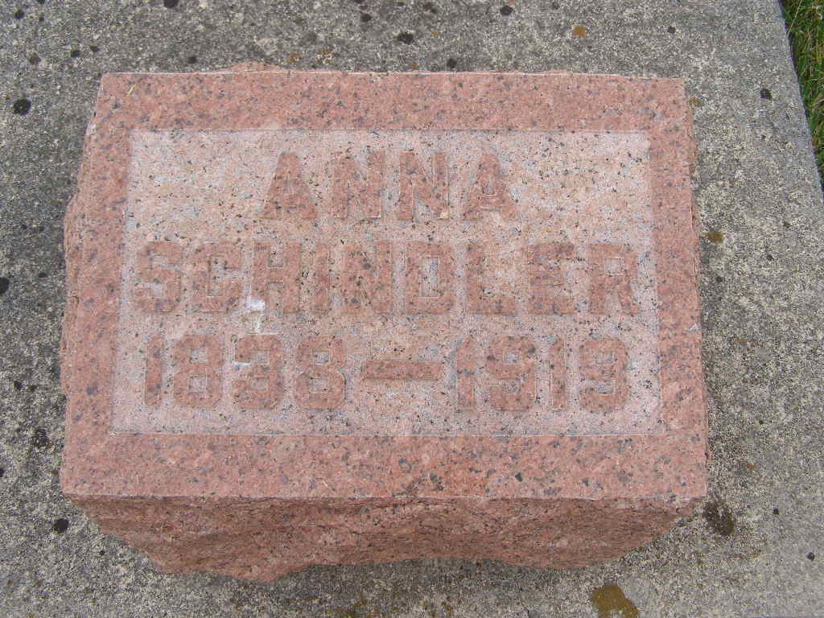
Photo by Shaunda Bedwell Opdycke

Anna Schindler
in the Indiana, U.S., Death Certificates, 1899-2017

Name Anna Schindler
[Anna Stucky]
Gender Female
Race White
Marital Status Married
Age 81
Birth Date 4 May 1838
Birth Place France
Death Date 26 Mar 1919
Death Place Hartford, Adams, Indiana, USA
Death Registration Date 1919
Father Nichlaus Stucky
Mother Barbara Frutiger
Spouse Jacob Schindler
Informant Henry Schindler; Berne, Indiana
Burial March 28, 1919; MRE Cemetery

