Amos Schindler
August 17, 1878 – August 23/1930

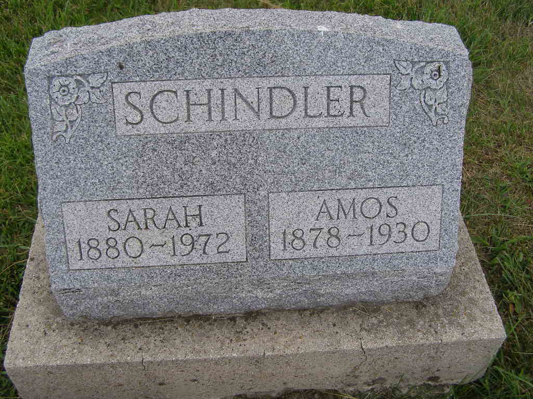
Photo by Shaunda Bedwell Opdycke

Amos Schindler
in the Indiana, U.S., Death Certificates, 1899-2017

Name Amos Schindler
Gender Male
Race White
Marital Status Married
Age 52
Birth Date 17 Aug 1878
Birth Place Indiana
Death Date 23 Aug 1930
Death Place Berne, Adams, Indiana, USA
Death Registration Date 1930
Father Jacob Schindler
Mother Anna S Stuckey
Spouse Sarah
Informant John Schindler; Berne, Indiana
Burial August 25, 1930; MRE Cemetery

