Alton Schindler
October 4, 1904 – January 21, 1989

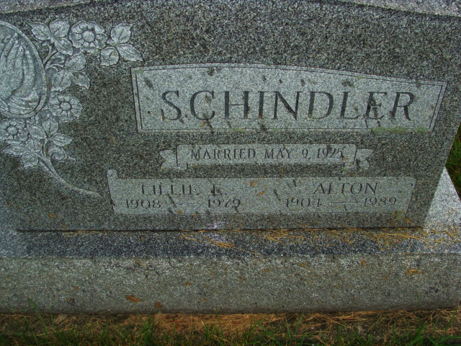
Photo by Alicia Kneuss

Alton Schindler, 84, Portland Community Care Center, died Saturday at 7:10 p.m.; he had been ill since Dec. 11, 1988.
Born Oct. 4, 1904 in Adams County to Rufus Schindler and Rebecca Luginbill- Schindler, He retired from Dunbar Furniture after 40 years of service in 1970 and married Lillie E. Moser in 1925; she preceded in death. He was a member of the West Missionary Church and lived in Adams County most of his life.
Surviving are two daughters, Mrs. Harriet Dustman, Berne; Mrs. John (Norma) Poorman, Berne; a son, Lester Schindler, Berne.
Calling is today from 2-9 p.m. and Tuesday from 8 a.m. to time of service at 10:30 a.m. Tuesday, at Yager-Kirchhofer Funeral Home, Rev William Lepley, assisted by Thomas Schindler, will officiate. Burial will be MRE Cemetery and memorials are to West Missionary Church Mission.

Unknown source
**

Indiana, U.S., Death Certificates, 1899-2017

Name Alton Schindler
Gender Male
Race White
Marital Status Widowed
Age 84
Birth Date 4 Oct 1904
Birth Place Adams County, Indiana
Death Date 21 Jan 1989
Death Place Portland, Jay, Indiana, USA
Death Registration Date 1989
Father Rufus Schindler
Mother Rebecca Luginbill
Informant Lester Schindler; son; Berne, Indiana
Burial January 24, 1989; MRE Cemetery; Berne, Indiana

