Alieda S. (Sprunger) Schindler
November 4, 1899 – September 6, 1960

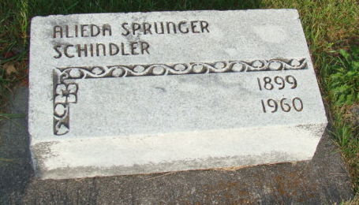
Photo by Alicia Kneuss

Alieda Schindler Dies Early Sunday
Mrs. Alieda Schindler, 60, owner and operator of the Schindler Electric store in Bern, died at 12:45 o'clock Monday morning at her home, 365 Bryant Street, Berne, after a year's illness of carcinoma.
She was born south of Berne Nov. 4, 1899, a daughter of David and Caroline Tschantz-Sprunger, and was married to John W. Schindler July 26, 1920. Her husband preceded her in death in 1946.
Mrs. Schindler was a member of the First Mennonite Church, the WMF of the church, and the Berne Chamber of Commerce.
Surviving are two sons, Maj. Hallman W. Schindler of Ottawa, Canada, and Vaughn B. Schindler of Berne; four grandchildren; three brothers, Milton Sprunger of Chicago, and Theodore and Herbert Sprunger, both of Berne and two sisters, Mrs. Frieda Boehr of Siloam Springs, Ark., and Miss Elma Sprunger, of Berne. A son, Ted Schindler, was killed in action in Italy in 1945. Two brothers and two sisters are also deceased.
Funeral services will be held at 10 a.m. Thursday at the First Mennonite Church, the Rev. Gordon Neuenschwander officiating. Burial will be in the MRE Cemetery. Friends may call at the Yager Funeral Home in Berne after 7 p.m. today.
Adams County, Indiana Historical Museum
Jan1958-Dec1960 Scrapbook, Image 51
Handwritten-Tues., Sept. 6, 1960

