Aldine E. (Amstutz) Schindler
May 17, 1890 – July 5, 1938

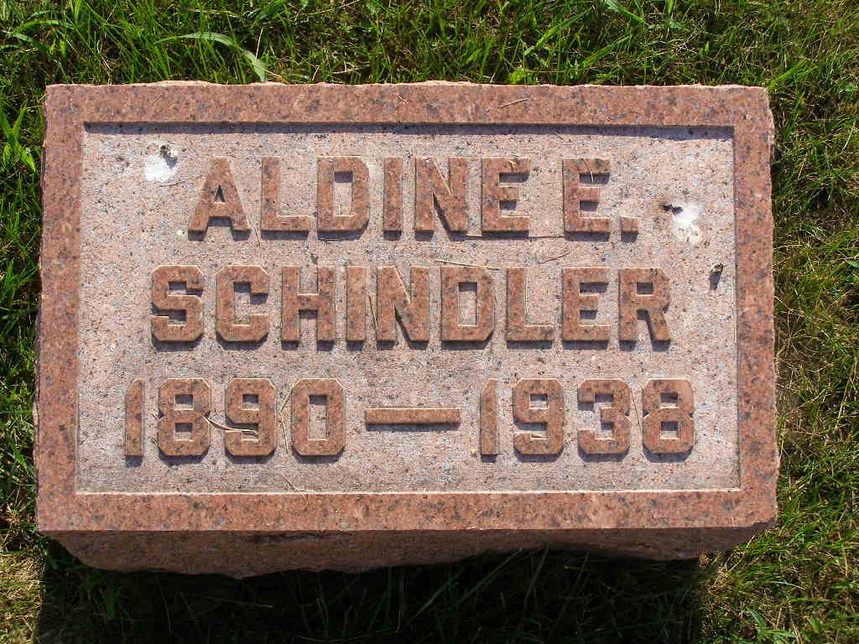
Photo by Shaunda Bedwell Opdycke

MRS. SCHINDLER DIES TUESDAY
Funeral For Mrs. Reuben Schindler To Be Held Friday

Mrs. Aldine Amstutz Schindler, aged 48, wife of Reuben Schindler of west of Berne, died at her home at 8:10 o'clock Tuesday evening, following an illness of several weeks. Mrs. Schindler suffered from heart disease and complications, according to the attending physician. Death came suddenly from a heart attack and was unexpected.
Mrs. Schindler was born in French township, May 17, 1890, a daughter of John and Lydia Neuhauser Amstutz. She was married to Mr. Schindler on April 17, 1917. Surviving are the husband, one daughter, Mildred, and one son, Marion, all at home. Two step-sons and one step-daughter also survive. They are Ornell, Ervin and Florence, all at home. The mother survives, Mrs. John Amstutz, of Berne, and the following brothers and sisters: Henry, Berne; Albert, Geneva; John and Mrs. Ida Beltz, both of Fort Wayne; Mrs. Tillie Roth, Canton, Ohio; Menno, Monroe; Ezra, Kidron, O.; Miss Ella Amstutz, Berne; Reuben, Celina and Loren, Orrville, Ohio.
The father and two brothers preceded, the brothers dying in infancy.
Mrs. Schindler was a member of the West Missionary church. The funeral will be at 9:30 o'clock Friday at the home and at 10 o'clock at the church, the Rev. C. J. Gerig officiating, assisted by Rev. N. J. Schmucker. Burial will be in the M.R.E. cemetery.

Adams County (IN) Historical Museum
1938 Scrapbook
Handwritten date: Thursday, July 7, 1938

