Flora Mae (Egle) Schilling
March 10, 1867 – April 22, 1910

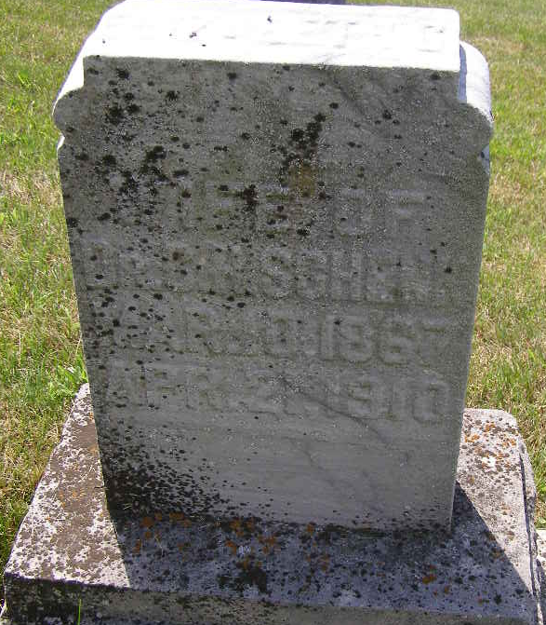
Photo by Shaunda Bedwell Opdycke

FLORA MAE SCHILLING, 93, died Tuesday [Feb. 18, 2002] at Woodcrest in Decatur. Born in El Higo, Mexico, she was a ward clerk at St. Mary's Hospital in Tucson, Ariz., and had also formerly worked at Decatur Industries, Decatur Casting in various places in Berne.
Her first husband, the Rev. Clarence E. Zimmerman, died in 1935; second husband, Thomas Garner, in 1948; and third husband, Arden Schilling, in 1988.
Surviving are two sons, David Lee Zimmerman of Mesa, Ariz., and Clarence E. Zimmerman of Hicksville, Ohio; a daughter, Wauneta Reinhart of Decatur; a sister Helen Stahly of Lincoln, Neb.; two step-daughters, Pat Meyers of Delphos, Ohio, and Marilyn Frey of Decatur; 13 grandchildren; 40 great-grandchildren; and seven great-great, grandchildren.
Services at 10 a.m. Saturday at Zwick & Jahn Funeral Home, Decatur. Calling from 2 to 8 p.m. Friday. Burial in M.R.E. Cemetery, Berne.

Unknown source

