Rebecca (Stauffer) Schenk
May 14, 1885 – September 11, 1962

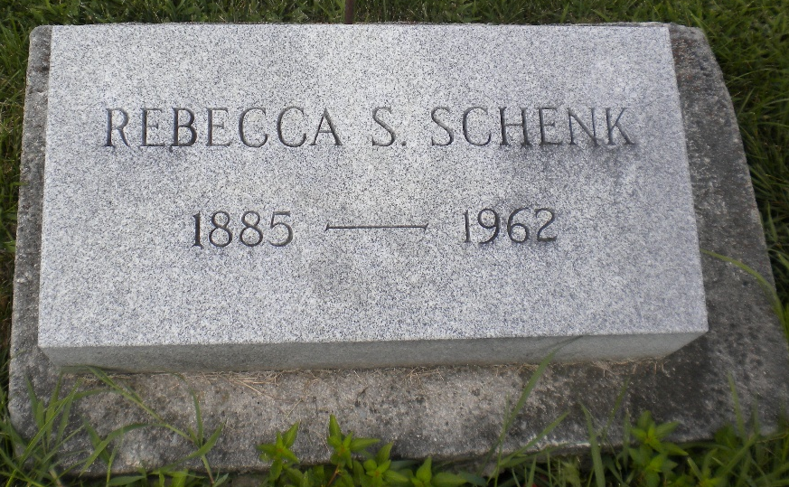
Photo by DSON1492

Indiana, U.S., Death Certificates, 1899-2017

Name Rebecca S Schenck
[Rebecca S Stauffer]
Gender Female
Race White
Marital Status Widowed
Age 77y 3m 26d
Birth Date 14 May 1885
Birth Place Geneva, Indiana
Death Date 10 Sep 1962
Death Place LaGrange, LaGrange, Indiana, USA
Death Registration Date 1962
Father Amos Stauffer
Mother Ellen Morrow
Informant Deloris Schenck, daughter
Burial 9-11-1962 M.R.E.

