Elizabeth Catherine (Atkinson) Schenk
March 10, 1867 – April 22, 1910

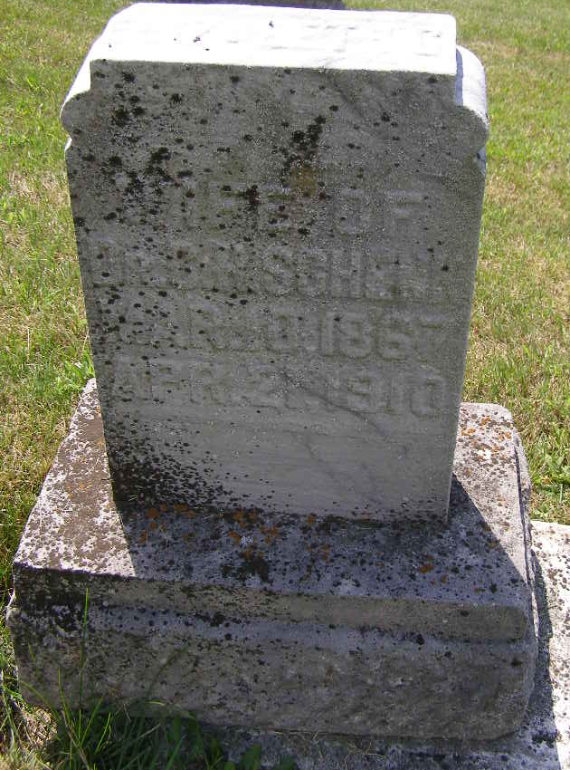
Photo by Shaunda Bedwell Opdycke

Indiana, U.S., Death Certificates, 1899-2017

Name Elizabeth C Schenk
[Elizabeth C Alkinson]
Gender Female
Race White
Marital Status Married
Age 43y 1m 11d
Birth Date 10 Mar 1867
Birth Place Indiana
Death Date 21 Apr 1910
Death Place Adams, Indiana, USA
Death Registration Date 1910
Father J R Alkinson
Mother Margarett Theurer
Spouse C H Schenk
Informant Dr. C.H. Schenk
Burial M.R.E. 4/23, 1910
**

Indiana, U.S., Marriage Certificates, 1960-2012

Name Elizabeth C Atkinson
Gender Female
Marriage License Date 29 Oct 1895
Marriage Date 30 Oct 1895
Marriage Place Jay, Indiana, USA
Spouse Charles H Schenk

