Dr. Charles Henry Schenk
October 30, 1870 – February 5, 1931

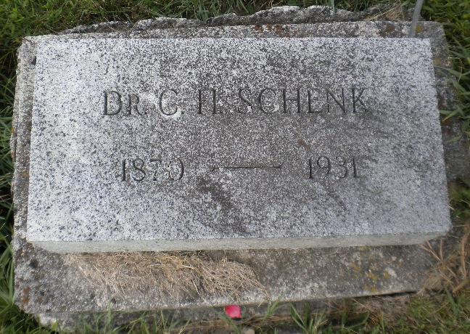
Photo by DSON1492

Indiana, U.S., Death Certificates, 1899-2017

Name Dr C. H Schenk
Gender Male
Race White
Marital Status Married
Occupation Physician
Age 60y 3m 5d
Birth Date 30 Oct 1870
Birth Place Indiana
Death Date 5 Feb 1931
Death Place La Grange, LaGrange, Indiana, USA
Death Registration Date 1931
Father G. F. Schenk b. Germany
Mother Christene Ruckweilt b. Germany
Spouse Rebecca Schenk
Informant Mrs. C.H. Schenk
Burial Berne, Indiana 2/8/1931
**

U.S., Veterans Administration Master Index, 1917-1940

Name Charles Henry Schenk or Shenk
Record Type Military Service
Birth Date 30 Oct 1870
Military Date 9 Jan 1919
Residence Place La Grange, Indiana

