Mary (Hawbaker) Schenbeck
January 15, 1888 – January 8, 1992

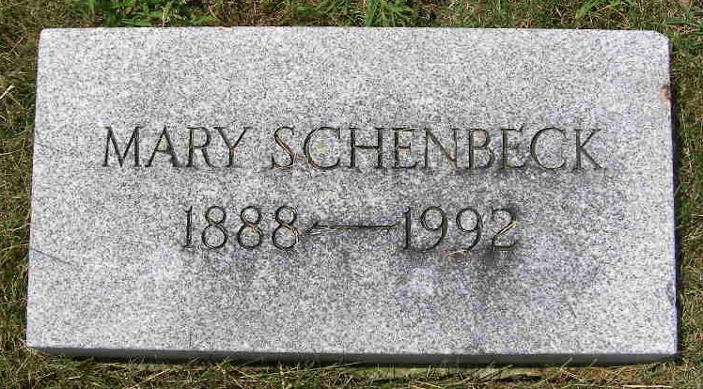

Indiana, U.S., Death Certificates, 1899-2017

Name Mary Schenbeck
[Mary Hawbaker]
Gender Female
Race White
Marital Status Widowed
Age 103
Birth Date 15 Jan 1888
Birth Place Adams County, Indiana
Death Date 8 Jan 1992
Death Place Berne, Adams, Indiana, USA
Death Registration Date 1992
Father Daniel Hawbaker
Mother Caroline Schaffter
Informant Brice Bauserman, Admin. First Bank of Berne
Burial 1/11/1992 M. R. E.

