Caroline (Ellenberger) Schenbeck
January 1, 1875 – August 8, 1965

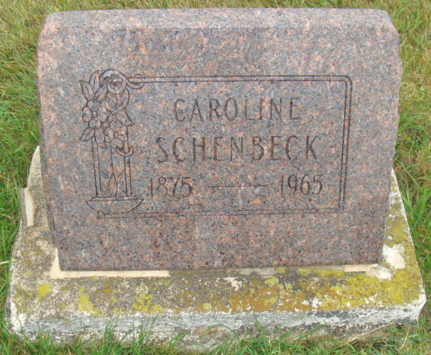
Photo by Alicia Kneuss

Indiana, U.S., Death Certificates, 1899-2017

Name Caroline E Schenbeck
[Caroline E Ellenberger]
Gender Female
Race White
Marital Status Widowed
Age 90
Birth Date 1 Jan 1875
Birth Place Indiana
Death Date 28 Aug 1965
Death Place Berne, Adams, Indiana, USA
Death Registration Date 1965
Father Henry Ellenberger
Mother Katie Baumgartner
Informant Mrs. Lorena Post, daughter
Burial M.R.E. 8/31/1965

