Christian Scheidegger
July 24, 1881 – May 31, 1977

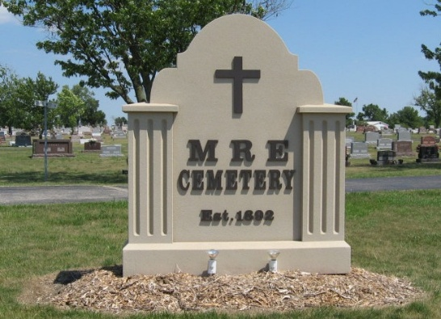
Photo by Tombstoner & Family

Christian Scheidegger

One of the oldest of Bern’s citizens passed away in the person of Christian Scheidegger, who died on Friday afternoon, June 23, at 3:30. He was born on Corgement, Canton Bern, Switzerland, on June 5, 1826.
He came to America in the year 1854 and lived on “Sonnenberg”, Ohio, for 10 years, after which he came to Indiana and married Fanny Sprunger, daughter of the late Peter E. Sprunger, on April 21, 1864. This union was blest with 12 children, of whom 2, one son and one daughter, died in their infancy. His wife preceded him over 17 years ago. He lived on the farm with his family until the year 1889 when he moved to town, where he moved three times, coming to his late residence about 3 years ago.
He has been a patient sufferer of rheumatism for many years, having had but little use of his lower limbs, consequently was seen very little around town. Death was a welcome guest for him from a world of suffering to a home of blessedness for which he was prepared. His death was due mostly from the infirmities of the ripe old age of 79 years and 18 days.
Two sons and eight daughters, and also 10 grandchildren survive to mourn the loss of a loving father. His brothers and sisters have all preceded him for several years. They all died in the old country. Many other relatives and friends are mourning over his departure.
The funeral occurred yesterday at 9 a.m. at the house and 9:30 at the Mennonite church, Rev. A. M. Clauser, of the Missionary church, where Grandpa Scheidegger attended, officiated at both places. Rev. A. M. Clauser preached in German and Rev. Eli Lantz, of the Defense- less Mennonite church west of Berne, in English.
The bereaved ones wish to express their sincere thanks for the sympathy and assistance given them during his illness and day of burial.

The Berne Witness, Adams County, Indiana
June 27, 1905

