Rose Anna (Liechty) Scheer
July 24, 1881 – May 31, 1977

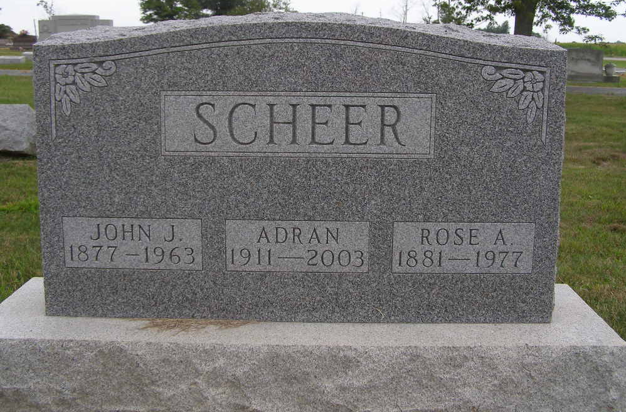
Photo by Shaunda Bedwell Opdycke

Indiana, U.S., Death Certificates, 1899-2017
Name Rosella Scheer
[Rosella Liechty]
Gender Female
Race White
Marital Status Widowed
Age 95
Birth Date 24 Jul 1881
Birth Place Switzerland
Death Date 31 May 1977
Death Place Decatur, Adams, Indiana, USA
Death Registration Date 1977
Father Christian E. Liechty
Mother Emma Lehman
Informant Elma Sullivan, sister
Burial MRE 6/2/1977

