Adran Ernest Scheer
October 11, 1911 – May 8, 2003

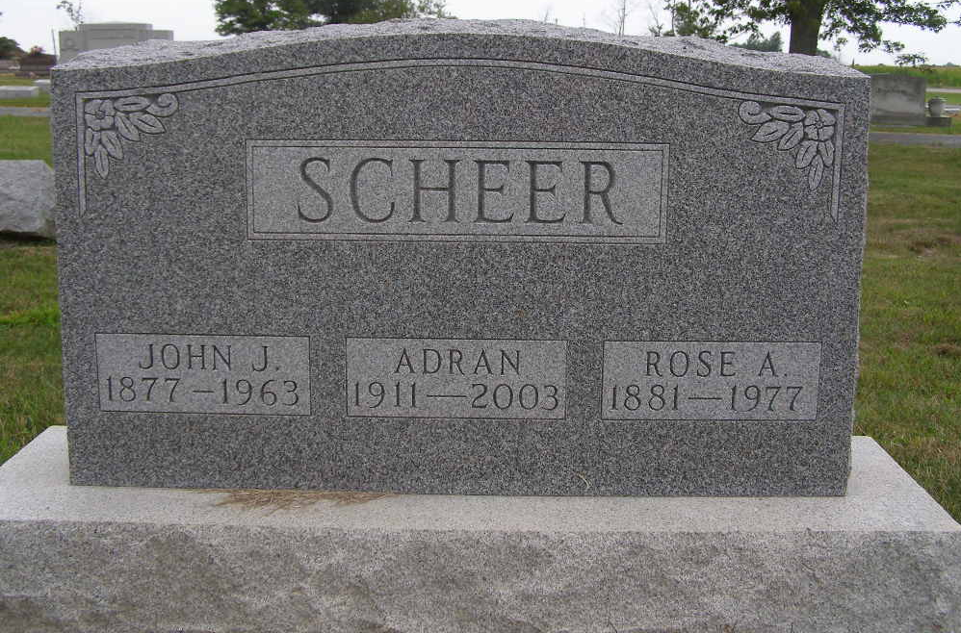
Photo by Shaunda Bedwell Opdycke

Indiana, U.S., Death Certificates, 1899-2017

Name Ernest A Scheer
Gender Male
Race White
Marital Status Never
Age 91
Birth Date 11 Oct 1911
Birth Place Berne, Indiana
Death Date 8 May 2003
Death Place Decatur, Adams, Indiana, USA
Death Registration Date 2003
Father John Scheer
Mother Rosie Lehman
Informant Arthur J. Heimann, POA
Burial M.R.E. Cemetery, 5/10/2003

