Frances Jeanette (Aeshliman) Schamerloh
March 12, 1919 – April 25, 1993

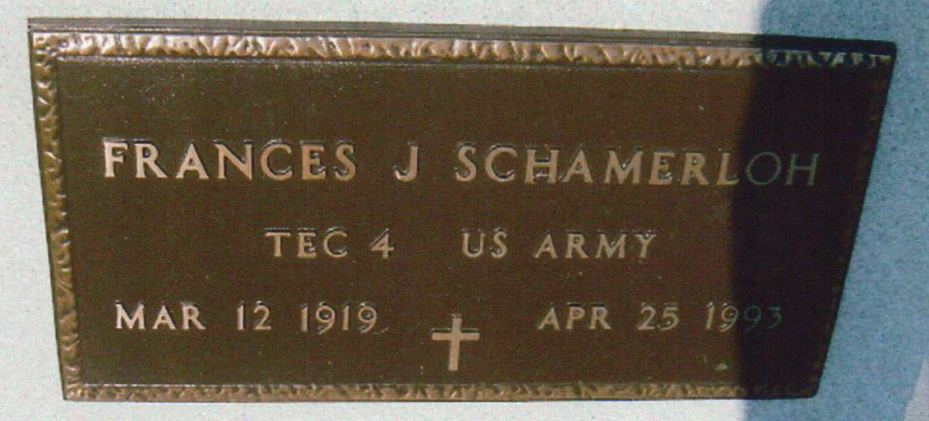
Photo by JC

Indiana, U.S., Death Certificates, 1899-2017

Name Frances J Schamerloh
[Frances J Aechliman]
Gender Female
Race White
Marital Status Divorced
Age 74
Birth Date 12 Mar 1919
Birth Place Adams County, Indiana
Death Date 25 Apr 1993
Death Place Decatur, Adams, Indiana, USA
Death Registration Date 1993
Father Emil Aechliman
Mother Ina Eley
Informant Greg Schamerloh, son
Burial M.R.E. 4/27/1993
**

Frances Jeanette Aeschlimann from tree Schroeder, Reiter, Lang-becker, Lipsack

Birth 12 Mar 1919 Berne, Adams, Indiana, USA
Marriage 17 Aug 1946 Adams, Indiana, USA
Death 25 Apr 1993 Decatur, Adams, Indiana, USA
Father Emil “Chick” Aeschlimann (1887-1930)
Mother Ina Silva Eley (1887-1965)
Spouse Arthur William Schamerloh (1912-1972)
56961 People 17 Records 20 Sources

