Treva M. (Soldner) Schaffter
August 11, 1924 – May 20, 2016

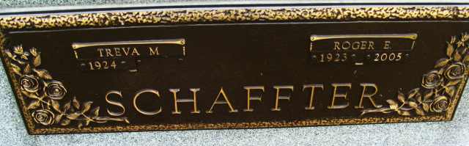
Photo by Alicia Kneuss

Treva M. Schaffter, 91, Geneva passed away on May 20, 2016 at Adams Woodcrest, Decatur. She was born on August 11, 1924 in Adams County to Clinton and Gertrude (Lehman) Soldner in Adams County, IN. She married Roger E. Schaffter on November 25, 1943.
Treva was a member of the St. John's United Church of Christ in Vera Cruz where she was active in the Women's Guild and children's Sunday School. She later became a member of the Cross Community Church in Berne. Her interests included making quilts and comforters for her family and Fort Wayne Crossroads. She worked at Ben Franklin, Gifford's Grocery Store and was a member of the the Good Neighbors Home Ec. Club. And she partnered with her husband on their dairy farm.
Survivors include a son, Charles D. (Susan) Schaffter of Berne, a daughter, Emma Marie Schaffter of Henderson NV, 8 grandchildren, and 14 great-grandchildren. Preceding in death are her parents, husband, Roger (2005), and a sister Janet Nussbaum.
Funeral services are Monday, May 23, 2016 at 11:00 am at the Yager-Kirchhofer Funeral Home with visitation from 10:00 am to time of services. Officiating is Pastor Chris Kruchkow. Burial is in the MRE Cemetery, Berne. Preferred memorials are to the Cross Community Church. Sign the guest book on-line at yagerkirchhofer.com

Yager-Kirchhofer Funeral Home, Adams County, Indiana
May 21, 2016

