Roger Earl Schaffter
February 6, 1923 – August 2, 2005

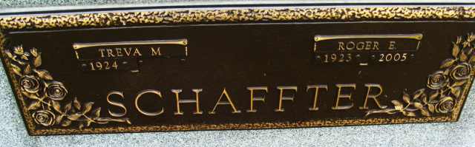
Photo by Alicia Kneuss

ROGER E. SCHAFFTER, 82, of Geneva, died Tuesday, Aug. 2, 2005, 10:47 p.m., at Swiss Village. Born Feb. 6, 1923, in Adams County, he was the son of the late Henry and Eva Eloise (Lane) Schaffter. He was a retired dairy farmer after 38 years; did custom farming; was a former employee of Denver Yoder Sawmill; was a member of St. John United Church of Christ, in Vera Cruz, where he held various church offices; and was a graduate of Bluffton High School, Bluffton.
He married Treva Soldner on Nov. 25, 1943, in Berne; she survives. Also surviving are daughter, Emma Marie Schaffter of Henderson, Nev.; son, Charles (Susan) Schaffter of Berne; one sister, Marjorie Moser of Bluffton; eight grandchildren; and eight great-grandchildren. He was also preceded in death by one brother, Robert.
Funeral service is 10 a.m. Saturday at Yager- Kirchhofer Funeral Home, Berne, with visitation one hour prior to service. Dr. Richard Pulling officiating. Visitation also from 3 to 7 p.m. Friday at the funeral home. Burial in M.R.E. Cemetery. Memorials to St. John United Church of Christ.

News-Sentinel, The (Allen County, Indiana)
Thursday, August 4, 2005

